# **1. GLOBAL ARCHITECTURE “LAB TEST IN THE CLOUD”**

1. Architecture diagram: 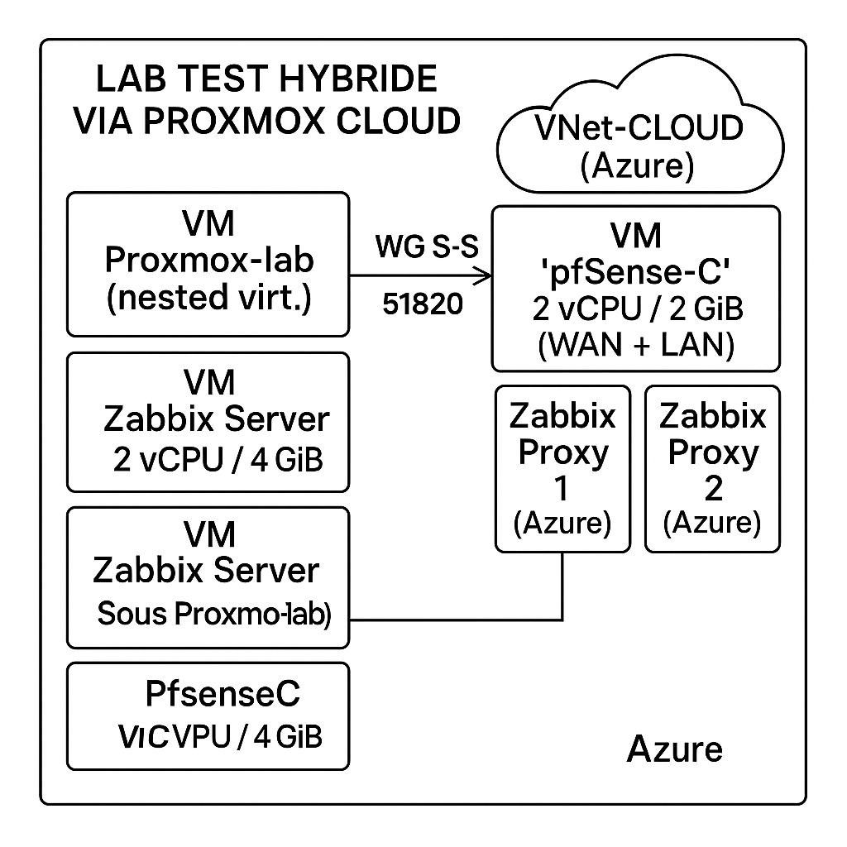

**- pfSense -L is nested in the Proxmox-lab VM (local, nested virt .).   
- The Zabbix Server VM remains under Proxmox-lab (local). - The   
WireGuard tunnel (UDP/51820) connects pfSense -L (local) to pfSense -C (hosted in Proxmox -Cloud in Azure).   
- pfSense -C is now deployed in a Proxmox -Cloud VM hosted on Azure.   
- Zabbix Proxies are installed in the Azure LAN-CLOUD.**

**NB:** **The original role of pfSense -C (direct Azure VM) has been replaced by a pfSense VM installed in a Proxmox VM hosted in Azure, to bypass Marketplace limitations.**

2. IP addressing plan :

2.1 Address allocation

| **Machine/Interface** | **IP address** |
| --- | --- |
| **pfSense -L (LAN)** | **10.0.10.1/24** |
| **pfSense -L (WAN)** | **192.168.1.61/30** |
| **pfSense -L (WG)** | **10.10.10.1/32** |
| **Proxmox -lab** | **10.0.10.2/24** |
| **Zabbix Server** | **10.0.10.11/24** |
| **pfSense -C (LAN)** | **10.30.20.1/24** |
| **pfSense -C (WAN)** | **10.30.0.4/24** |
| **pfSense -C (WG)** | **10.10.10.2/32** |
| **Zabbix Proxy 1** | **10.30.20.10/24** |
| **Zabbix Proxy 2** | **10.30.20.11/24** |

2.2 Gateway Configuration

| **Network** | **Default Gateway​** |
| --- | --- |
| **WAN-LOCAL** | **192.168.1.62** |
| **LAN-LOCAL** | **10.0.10.1 ( pfSense -L)** |
| **WireGuard Tunnel** | **pfSense -L ↔ pfSense -C** |
| **WAN-CLOUD (Azure)** | **10.30.0.4 ( pfSense -C)** |
| **LAN-CLOUD (Azure)** | **10.30.10.1 ( pfSense -C)** |

**2. Preparation of Virtual Machines**

**1.** **List of VMs .**

| VM | Location | Role |
| --- | --- | --- |
| Proxmox-lab | Local (on- premise ) | Local hypervisor ( pfSense -L and Zabbix Server) |
| pfSense -L | Under Proxmox-lab | Firewall local, NAT, tunnel WireGuard client |
| Zabbix Server | Sous Proxmox-lab | Serveur de supervision centralisée |
| Proxmox-Cloud | Azure (WAN-CLOUD) | Hyperviseur cloud (nested virt. pour pfSense-C) |
| pfSense-C | Sous Proxmox-Cloud | Firewall cloud, NAT, tunnel WireGuard serveur |
| Zabbix Proxy-1 | Azure (LAN-CLOUD) | Proxy Zabbix |

**2. Creation of resource group**

****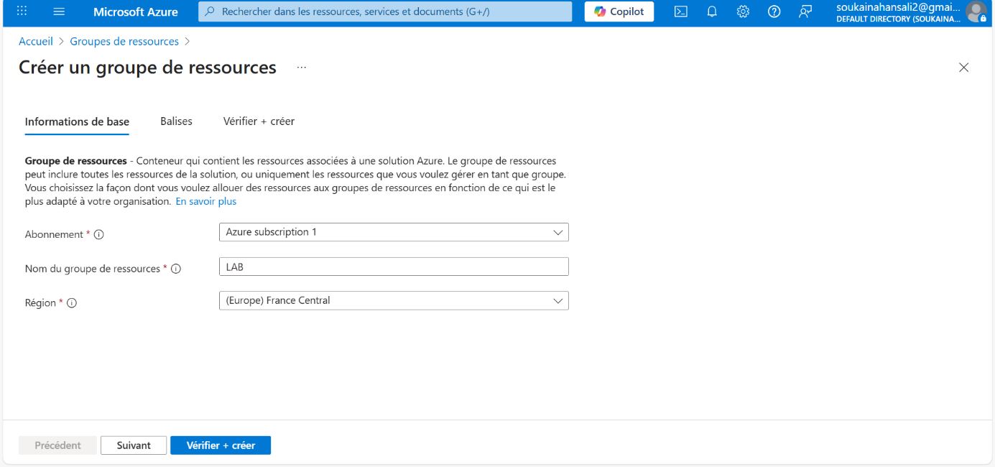

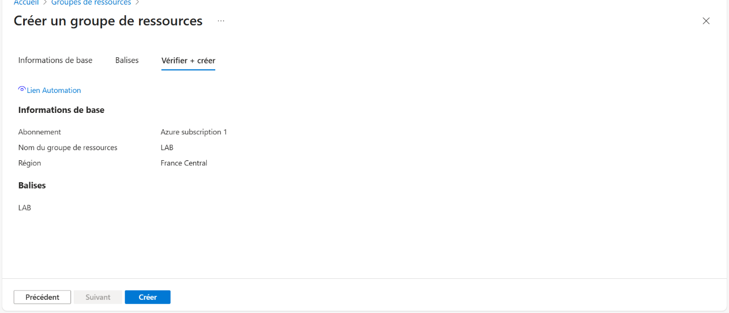



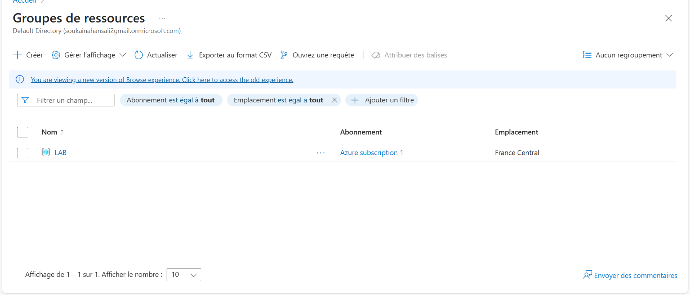3. Create the virtual network and subnets

* In the Azure Portal → **Virtual Networks** → **+ Add**

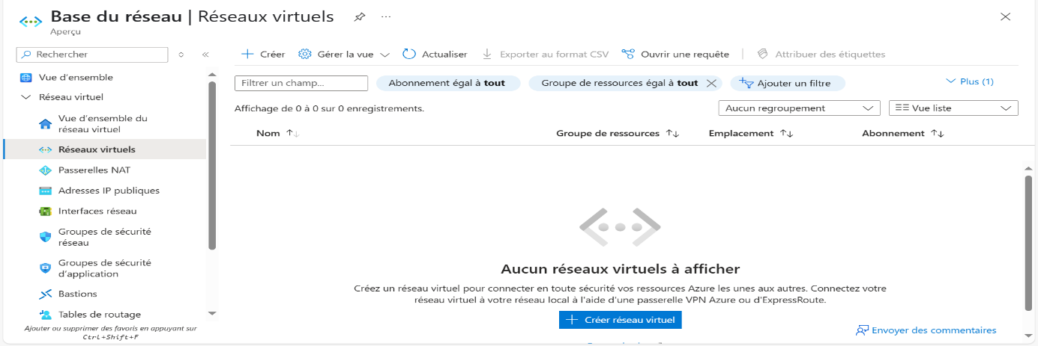

* Settings:
  + **Resource Group** : LAB
  + **Name** : LAB- VNet
  + **CIDR address(es)** : 10.30.0.0/16
  + **Region** : Central France

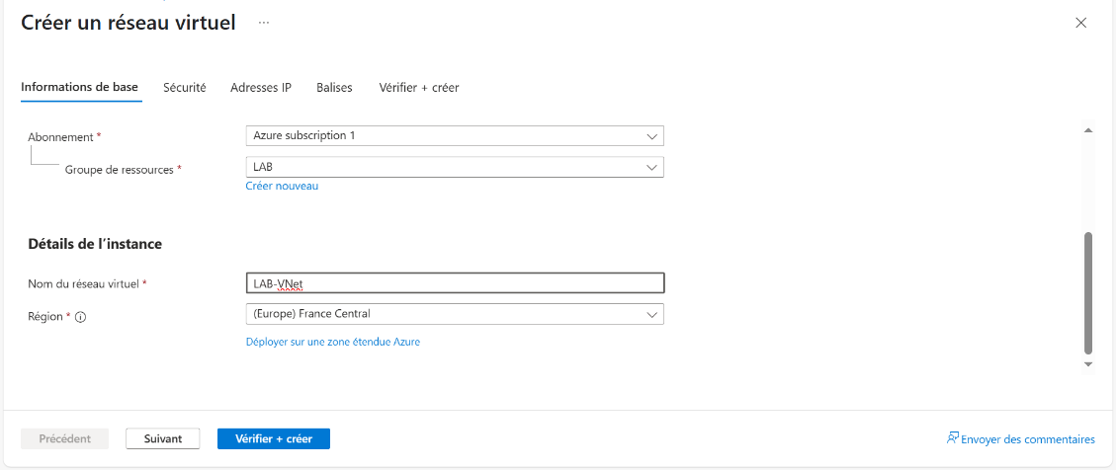

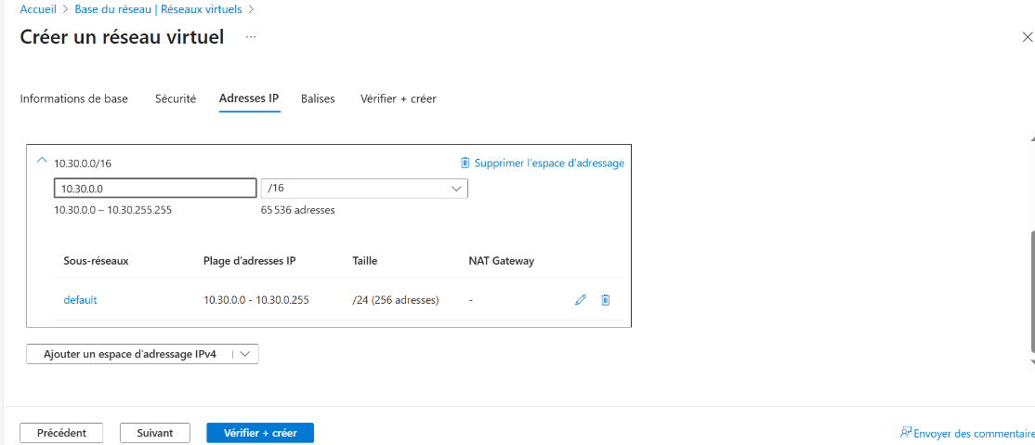

* **Subnets** (2):
* WAN-LOCAL: 10.30.1.0/24
* LAN-CLOUD: 10.30.2.0/24
* **LAN-PFSENSE-C:** 10.30.20.0/24

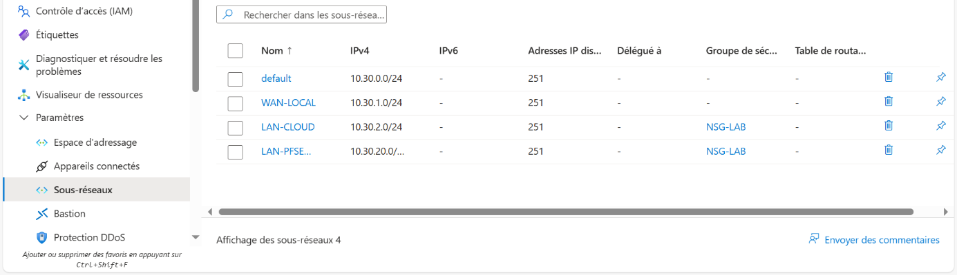

4 . Create an **NSG (Network Security Group):**

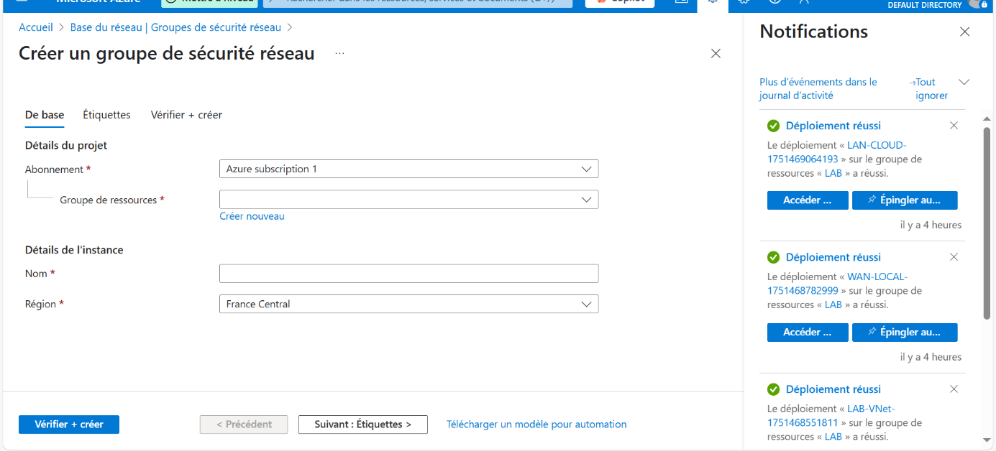

* **Name** : NSG-LAB
* **Resource Group** : LAB
* **Region** : Central France
* 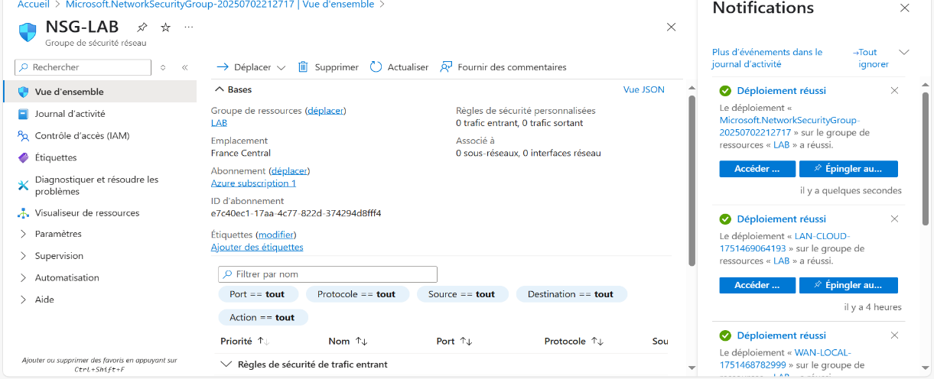

Inbound Security Rules

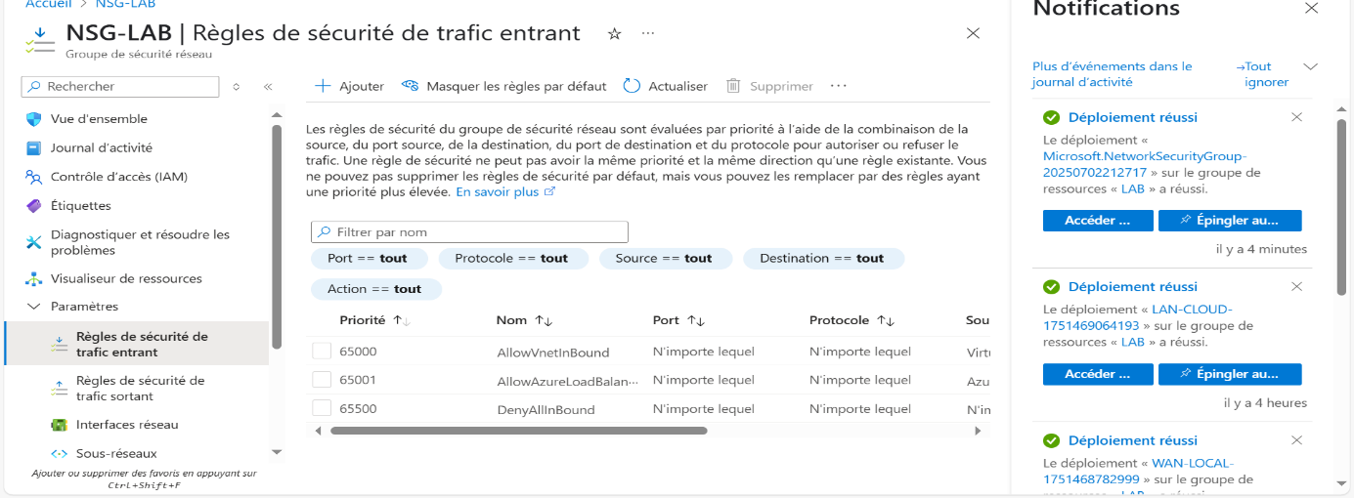

• Allow -WG, UDP port 51820, priority 1010

• Allow -HTTPS, TCP port 443, priority 1020

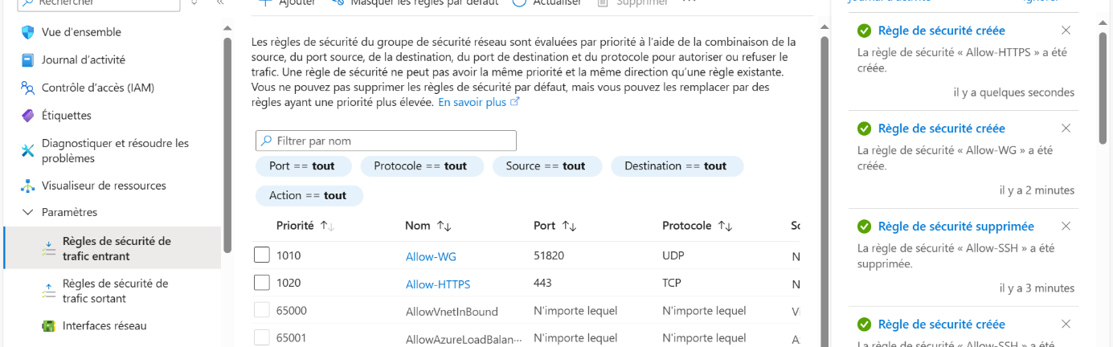

Associate with subnet:

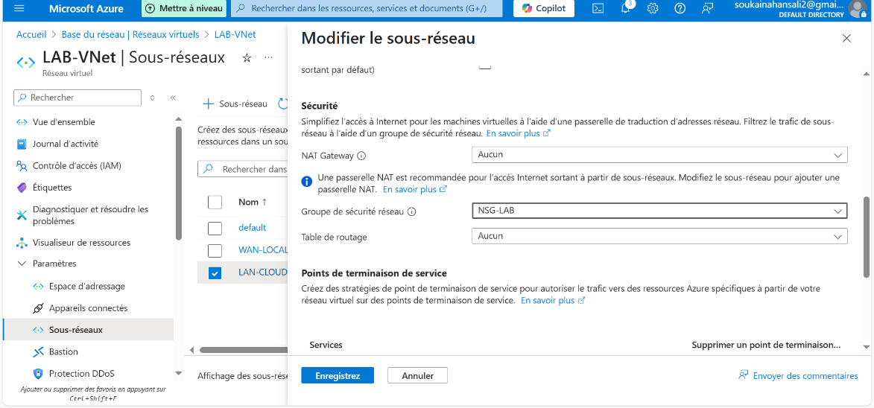

**5. Create WAN-CLOUD**

* Image: Debian 12 Bookworm
* Recommended size: **B2ms or D- series compatible nested virtualization**
* Static public IP
* Subnet: WAN-LOCAL (10.30.1.0/24)

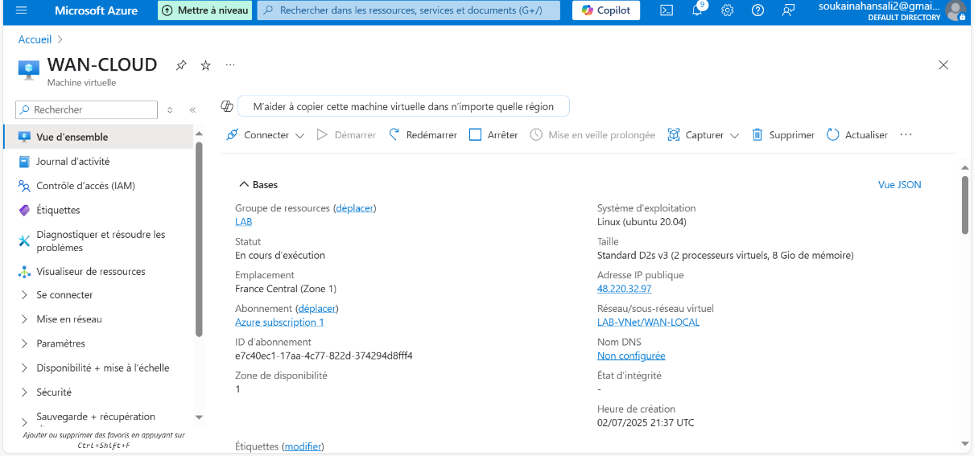

Proxmox Installation:

Proxmox is installed on debian 12 bookworm using the commands specified in <https://pve.proxmox.com/wiki/Install_Proxmox_VE_on_Debian_12_Bookworm>

To install Proxmox VE on Debian 12 Bookworm, first add hostname to /etc/hosts and then add the Proxmox VE repository using pve-no-subscription. Import the Proxmox GPG key and verify it with sha512sum. Update the package list and run a full upgrade. Next, install the Proxmox VE kernel and reboot the system. After reboot, install the main Proxmox VE packages including proxmox-ve, postfix, open-iscsi, and chrony. Remove the default Debian kernel (linux-image-amd64 and linux-image-6.1*) and update GRUB. Optionally, remove os-prober to keep the GRUB menu clean. Once complete, the Proxmox web interface can be accessed at https://<your-server-ip>:8006.

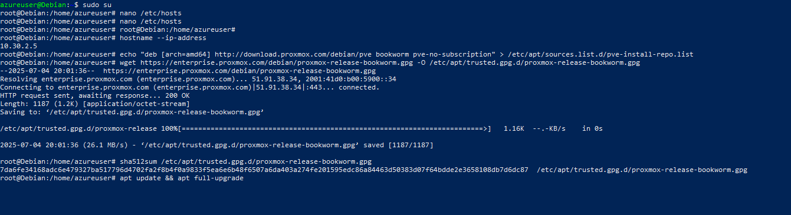

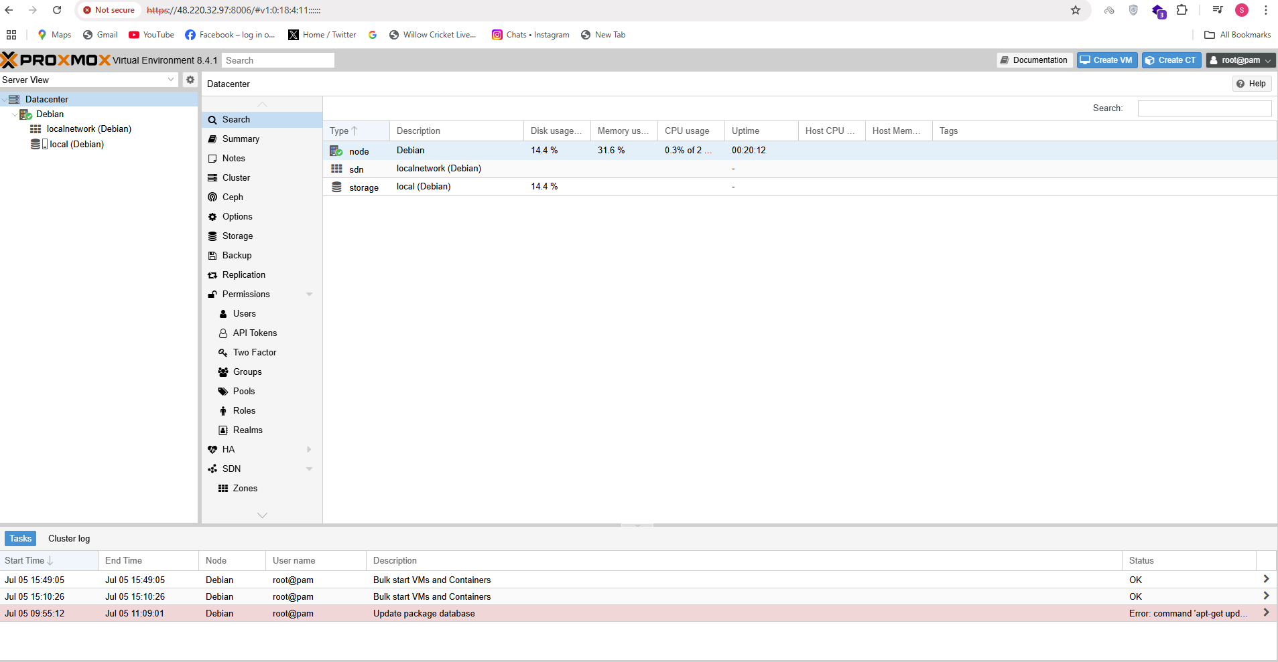

PFSense Installation on Proxmox:

To install pfSense in Proxmox VE, begin by uploading the pfSense ISO image to the Proxmox local storage. Once uploaded, navigate to the Proxmox interface and select **"Create VM"**. Proceed through the setup wizard, specifying the VM name, selecting the uploaded ISO under the "OS" section, and configuring the desired system resources such as disk size, CPU, and memory. At this stage, leave the network settings unconfigured, as network interfaces will be assigned later by attaching two Linux bridges to represent the WAN and LAN connections.

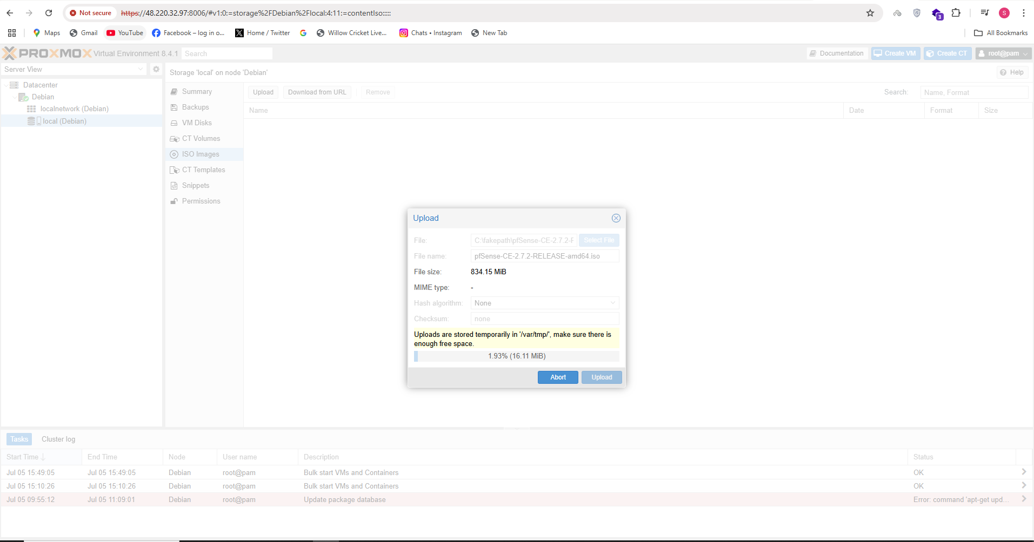

After completing the initial VM creation, proceed to configure networking by adding two Linux bridges in the Proxmox host—vmbr0 and vmbr1. These will serve as the WAN and LAN interfaces, respectively. Once the bridges are created, edit the pfSense VM configuration and add two network devices. Assign vmbr0 to net0 to function as the WAN interface, and vmbr1 to net1 to serve as the LAN interface. This setup ensures proper network segmentation and connectivity within the virtual environment.

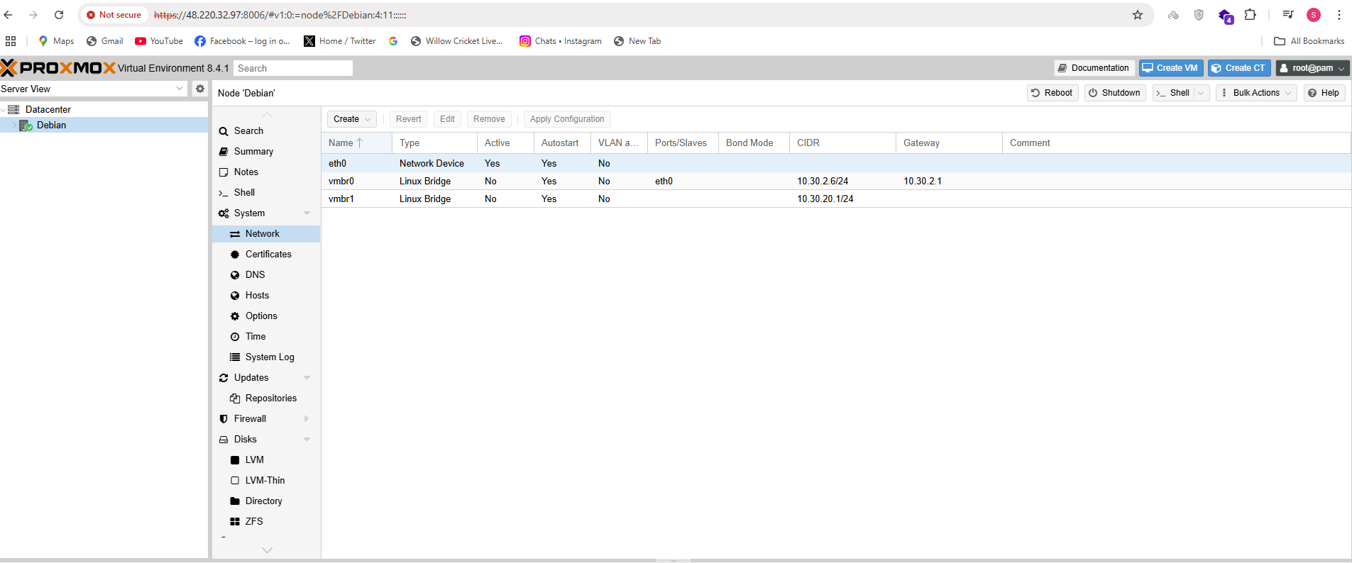

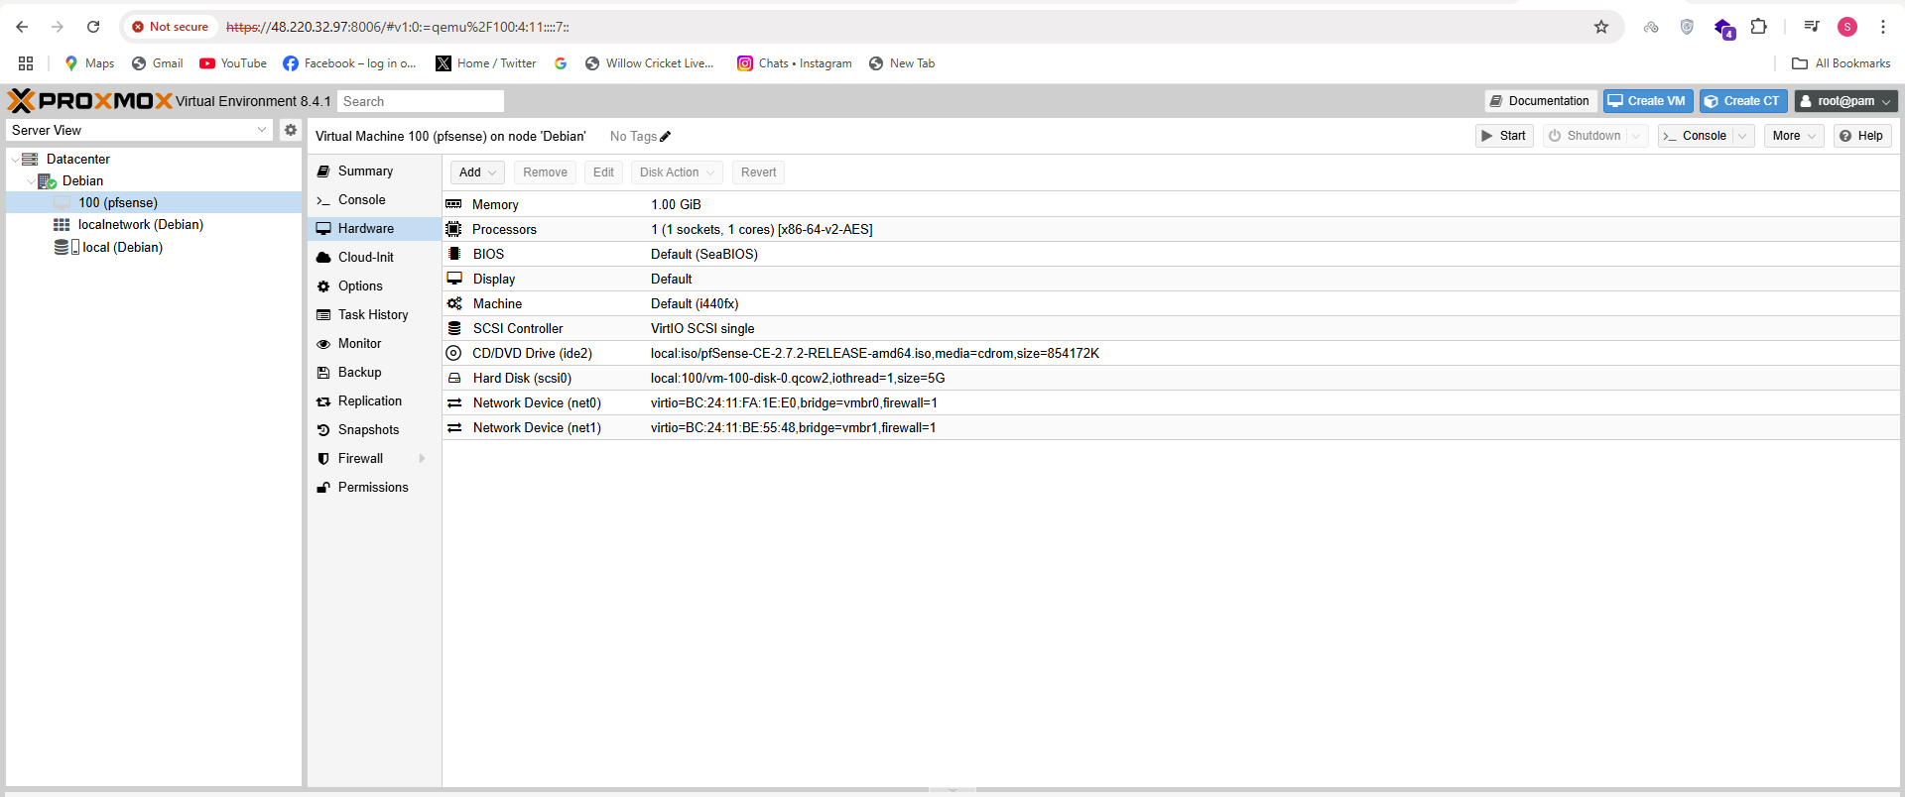

Proceed with the installation of the pfSense virtual machine by following the on-screen prompts within the pfSense installer. Once the installation is complete and the system has rebooted, configure the LAN interface by assigning it a static IP address of 10.30.20.1/24. After setting the LAN IP, enable the DHCP server on this interface to allow other virtual machines to automatically receive IP addresses. Define an appropriate DHCP range—for example, 10.30.20.2 to 10.30.20.22—to ensure efficient address allocation within the subnet.

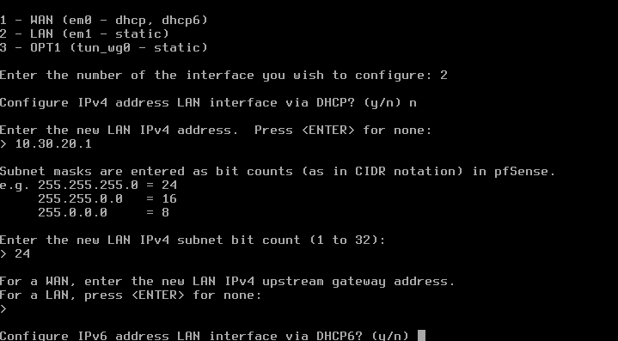

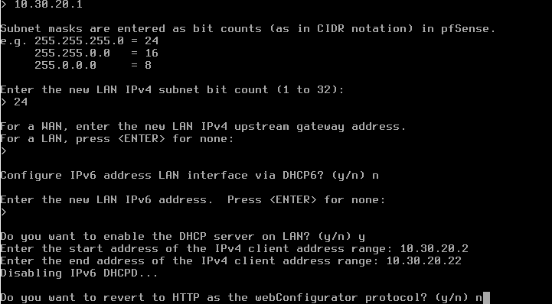

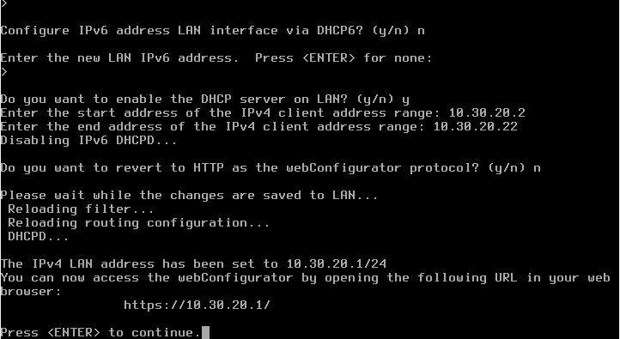

PFSense Installation on Proxmox (Local):

Begin by installing Proxmox VE on the local system using the official Proxmox ISO. Follow the guided installation process, including disk selection, root password configuration, and network settings. Once installation is complete and the system has rebooted, access the Proxmox web interface through https://<your-local-ip>:8006.

Next, upload the pfSense ISO to the local Proxmox storage and create a new virtual machine. Follow the VM creation wizard, selecting the uploaded pfSense ISO, configuring CPU, memory, and disk size according to your requirements. Initially, skip network configuration during VM creation.

After the VM is created, add two Linux bridges on the Proxmox host: vmbr0 (for WAN) and vmbr1 (for LAN). Then, edit the pfSense VM settings to add two network interfaces—attach vmbr0 to net0 for the WAN interface and vmbr1 to net1 for the LAN interface.

Proceed to install pfSense within the VM. Once installed and the system has rebooted, configure the LAN interface with a static IP address of 10.0.10.1/24. Enable the DHCP server on the LAN interface and define a suitable address range, such as 10.0.10.2 to 10.0.10.22, to allow connected virtual machines to obtain IP addresses dynamically. This completes the local Proxmox and pfSense setup with proper LAN configuration.

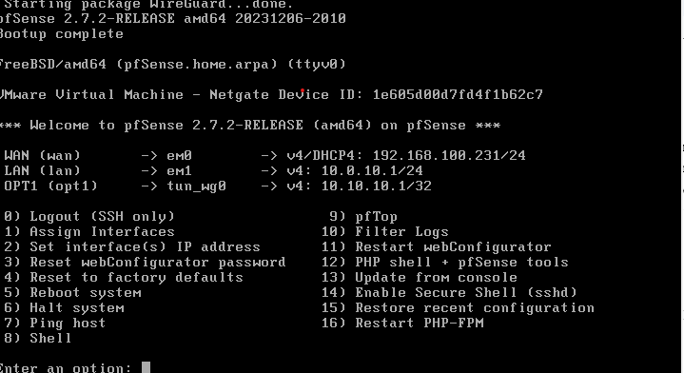

PFSense Features:

Access the pfSense web interface by navigating to https://<LAN-IP>:443 in a web browser. Log in using the default credentials: Username: admin and Password: pfsense. Upon first login, follow the initial setup wizard to configure basic system settings, including setting a new secure administrative password to replace the default for enhanced security.

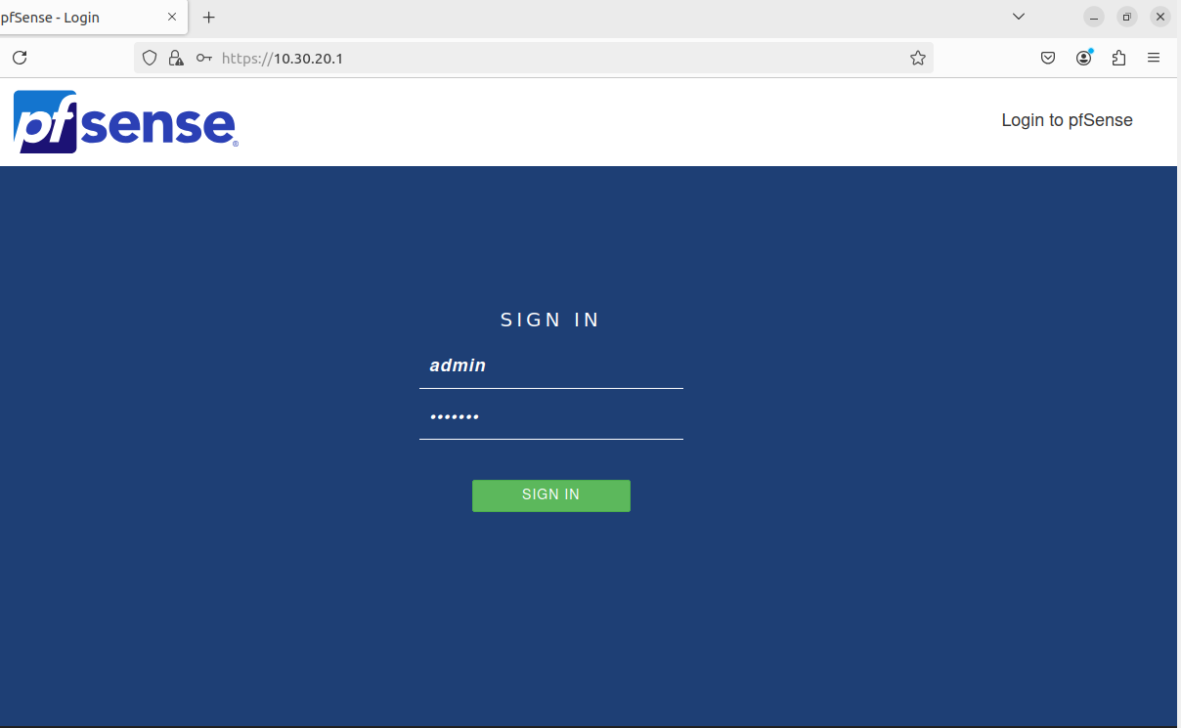

pfSense offers a comprehensive set of features for network management. **Interface assignment** allows administrators to configure and manage multiple network interfaces (WAN, LAN, and OPT), enabling segmentation and routing between networks.

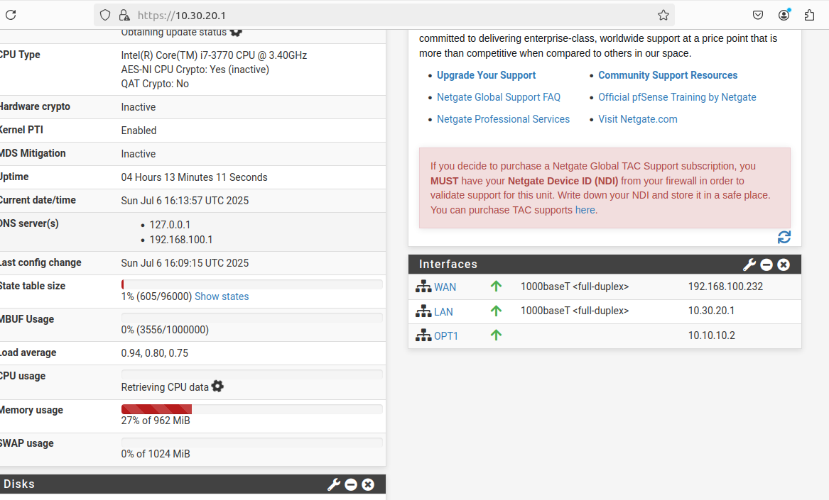

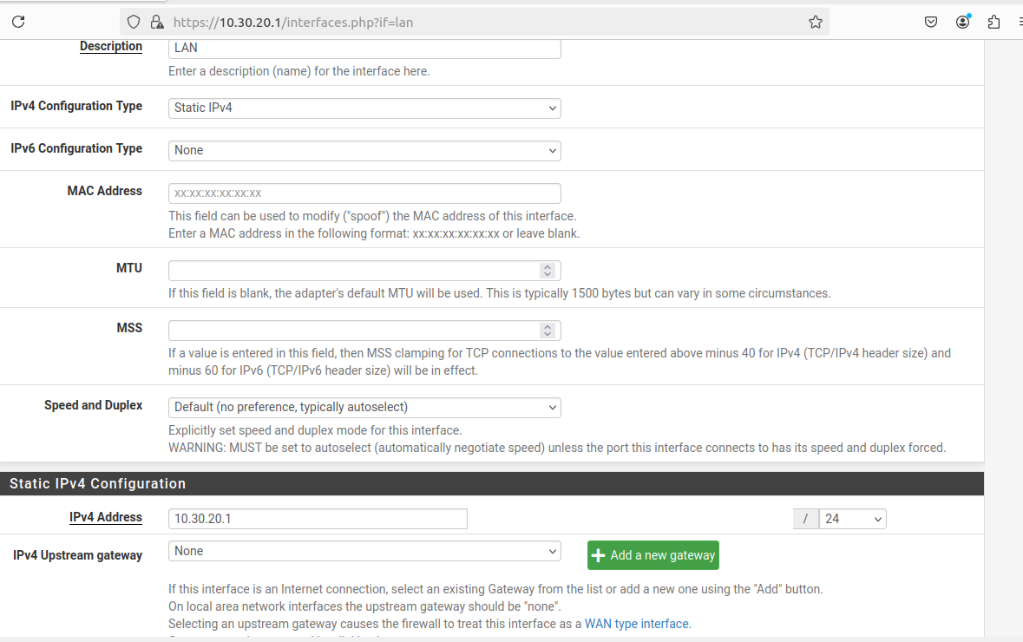

**Routing** features include support for static routes, dynamic routing protocols, and policy-based routing to direct traffic as needed.

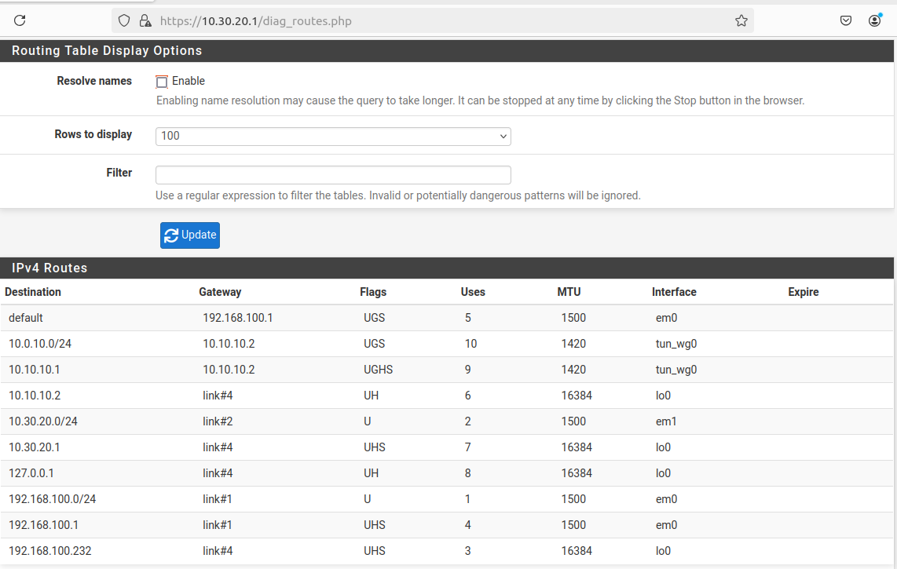

**Aliases** provide a flexible way to group IP addresses, networks, or ports under a single name for simplified rule management.

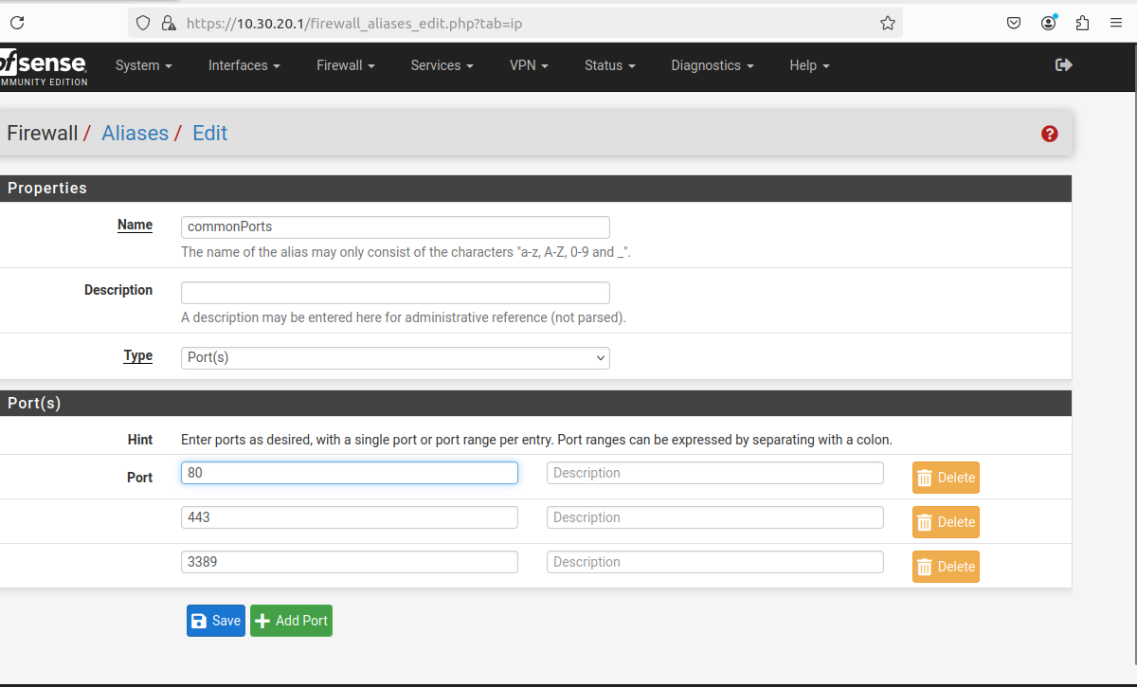

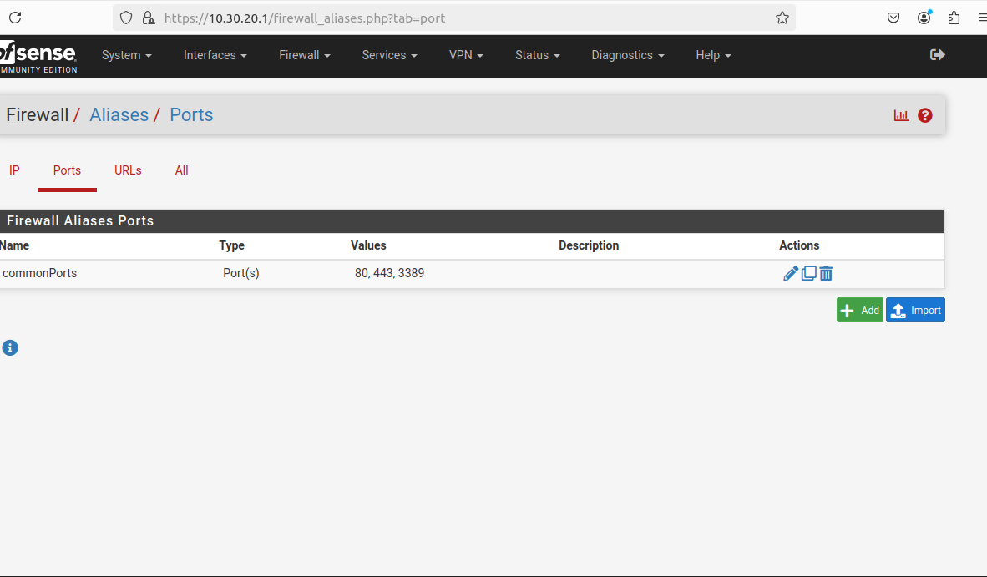

**NAT (Network Address Translation)** capabilities include port forwarding, outbound NAT, and 1:1 NAT, enabling effective management of traffic between internal and external networks. These features make pfSense a powerful and flexible firewall and routing platform suitable for a wide range of networking environments.

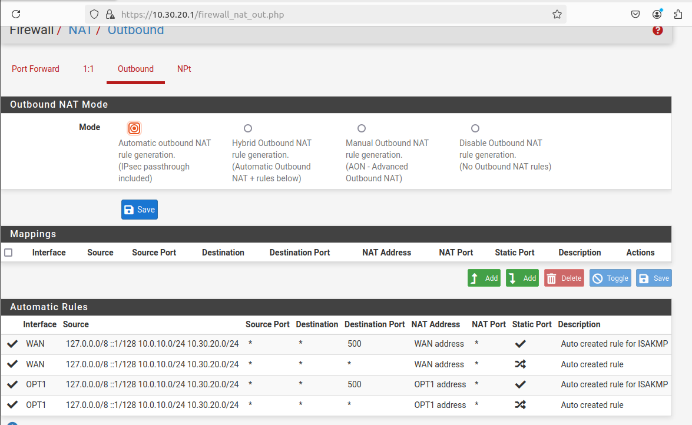

WireGuard Site-to-Site Tunnel:

With the network configurations finalized on both the local (pfSense-L) and cloud (pfSense-C) virtual machines, proceed with the setup of WireGuard to establish a secure site-to-site VPN tunnel. Begin by accessing the pfSense web interfaces of both instances. Navigate to **System > Package Manager > Available Packages**, search for **WireGuard**, and install the package on both pfSense-L and pfSense-C. This will enable WireGuard functionality and prepare both firewalls for tunnel configuration and peer association.

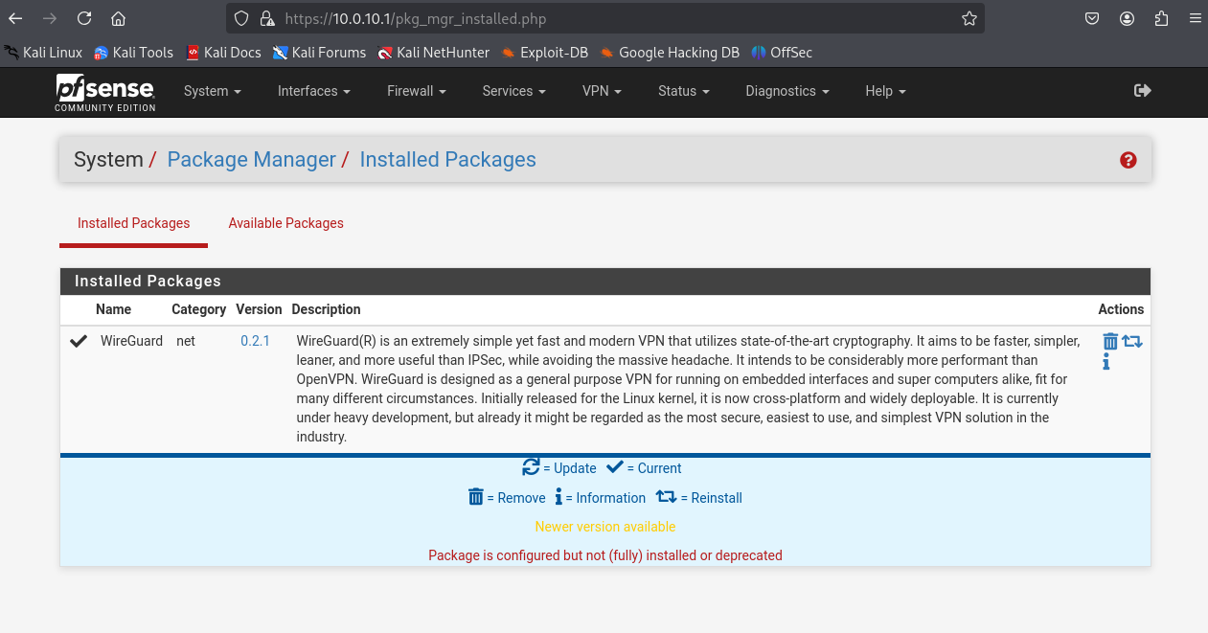

Next, enable WireGuard on both pfSense-L and pfSense-C. Navigate to **VPN > WireGuard** and select the **Enable WireGuard** checkbox. Proceed to create a new tunnel on each instance by clicking **Add Tunnel**, assigning it the name wg0, and setting the **Listen Port** to 51820. Generate a public-private key pair for each tunnel instance—ensure that the public key is securely saved, as it will be required during peer configuration on the opposite pfSense node.

After creating the tunnel, go to **Interfaces > Assignments**, and assign the newly created WireGuard tunnel (wg0) to a new interface. And, give it a static IPv4 address. Once assigned, configure the interface as needed under **Interfaces > OPTx** (where x is the assigned interface number), enabling it and giving it a recognizable name such as WG0. This interface will serve as the gateway for encrypted traffic between the local and cloud environments.

For the WireGuard tunnel configuration, assign the following static IPv4 addresses to the wg0 interfaces:

* On **pfSense-C**, assign the interface wg0 the IP address 10.10.10.2/32.
* On **pfSense-L**, assign the interface wg0 the IP address 10.10.10.1/32.

These addresses will serve as the internal tunnel endpoints for the site-to-site VPN. Ensure the /32 subnet is used, as each endpoint communicates directly with the other over a point-to-point link. These IPs will be used in the peer configuration to define allowed IPs and routes between the two sites.

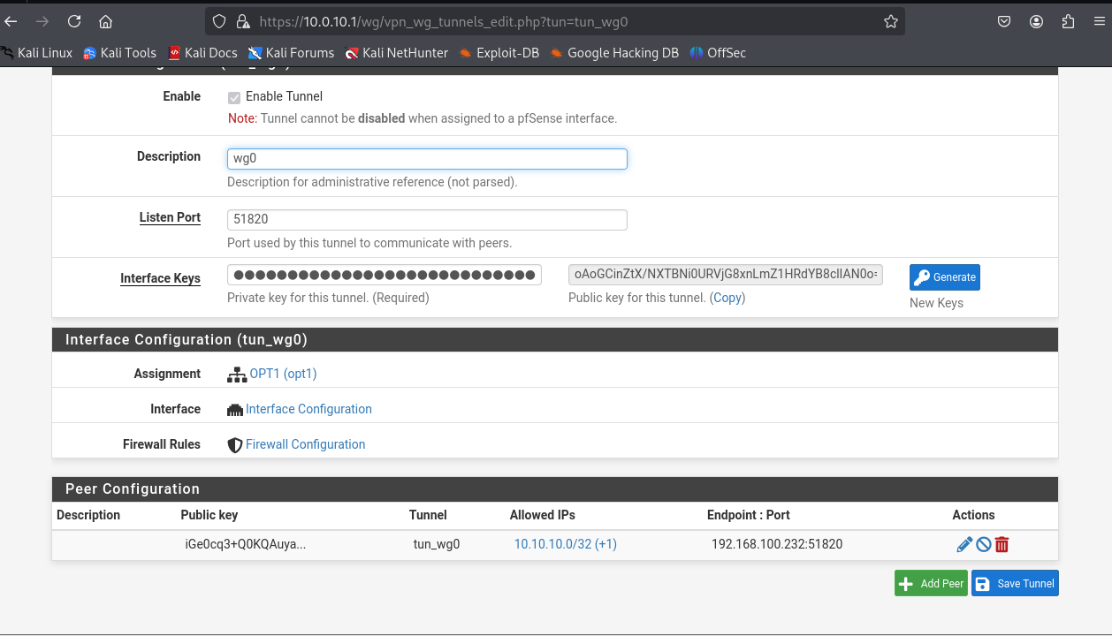

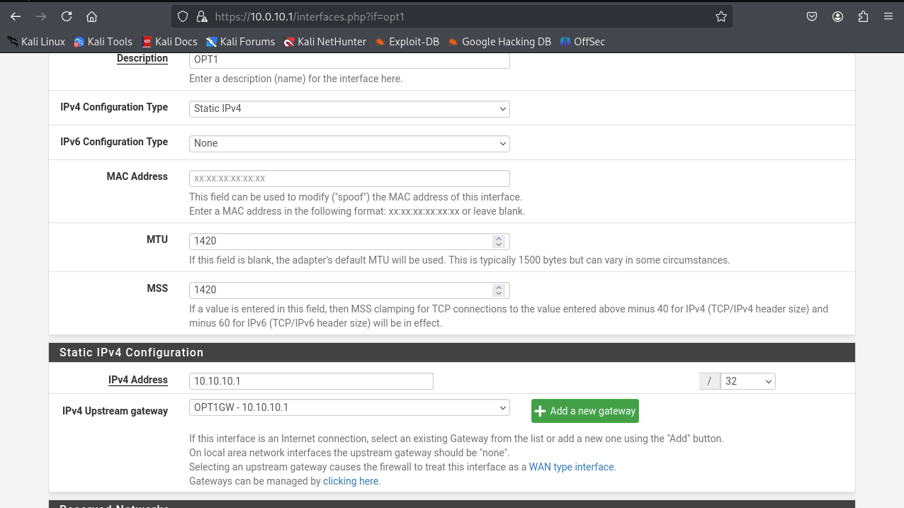

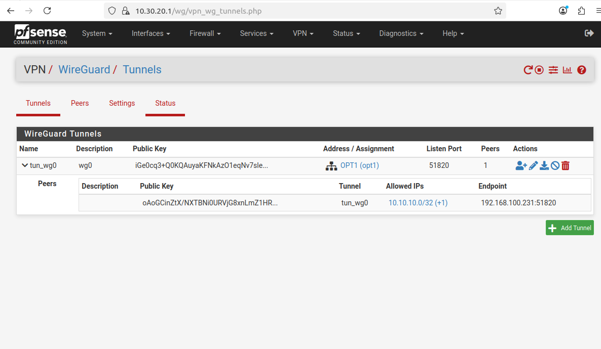

Proceed to configure the WireGuard peer settings on both pfSense-L and pfSense-C. In each pfSense instance, navigate to **VPN > WireGuard**, edit the existing tunnel (wg0), and add a new peer entry.

Exchange the **public keys** between the two pfSense instances by copying the public key generated on one and pasting it into the **Public Key** field of the peer configuration on the other. **Uncheck** the **Dynamic Endpoint** option to manually define the peer’s address.

In the **Endpoint Address** field, enter the **WAN IP address** of the remote pfSense instance, and set the **Port** to 51820 on both ends to match the configured WireGuard listening port.

In the **Allowed IPs** section, define the networks that should be routed through the tunnel:

* First, enter 10.10.10.0/32 to represent the tunnel subnet.
* Second, specify the **LAN subnet of the remote site**.  
   For example:  
  + On **pfSense-L**, enter 10.30.20.0/24 (cloud LAN).
  + On **pfSense-C**, enter 10.0.10.0/24 (local LAN).

This configuration ensures encrypted communication between the two sites and proper routing of traffic destined for the remote LANs through the WireGuard tunnel.

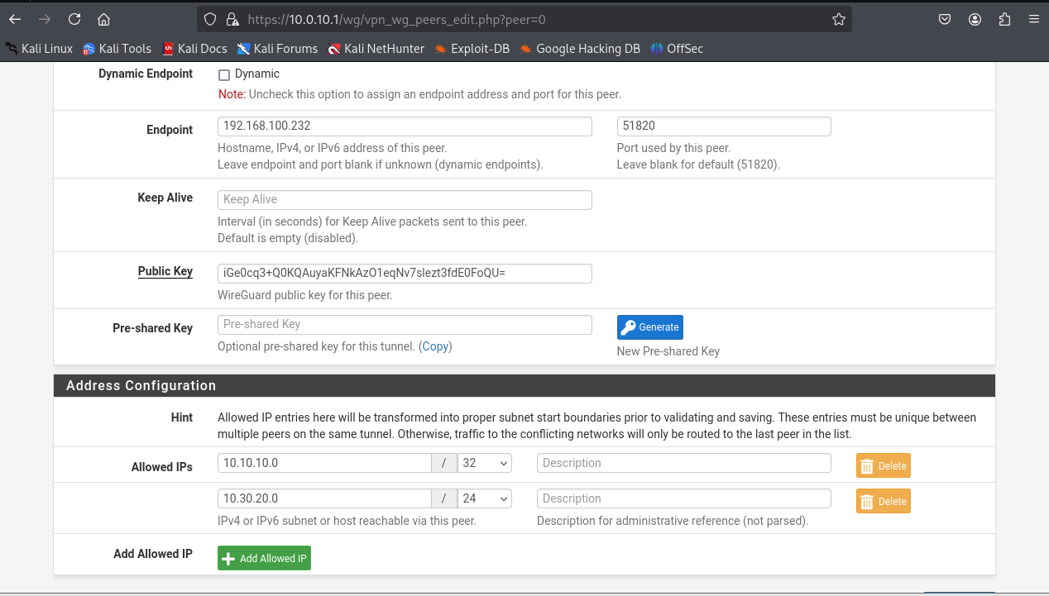

Configure a gateway and static route on both pfSense-L and pfSense-C by assigning the WireGuard interface as the gateway interface and using the peer's tunnel IP as the monitor address. Ensure the default IPv4 gateway remains assigned to the WAN interface. Then, add a static route on each pfSense instance pointing to the remote LAN subnet via the newly created WireGuard gateway. This setup ensures proper routing of inter-site traffic through the WireGuard tunnel.

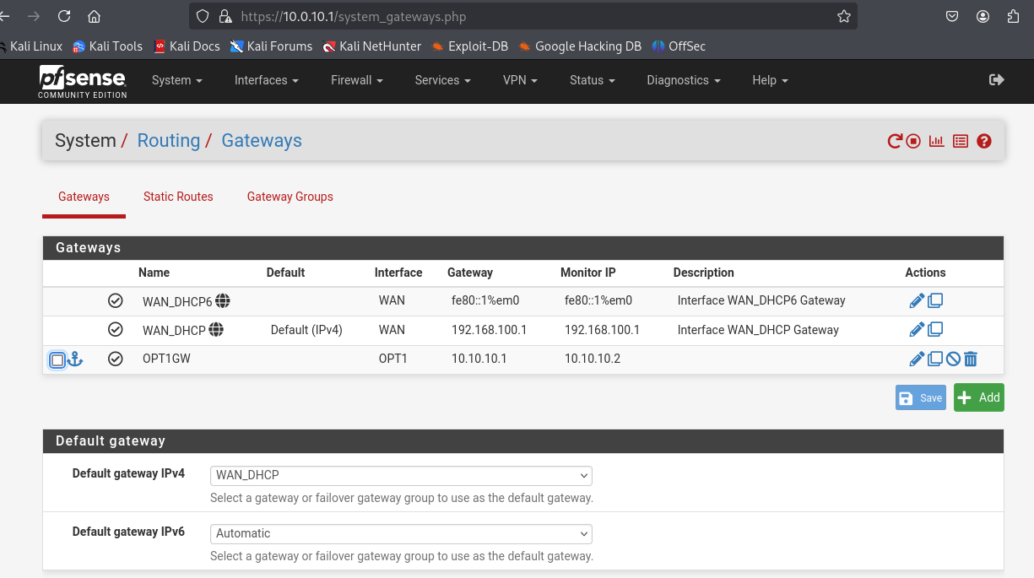

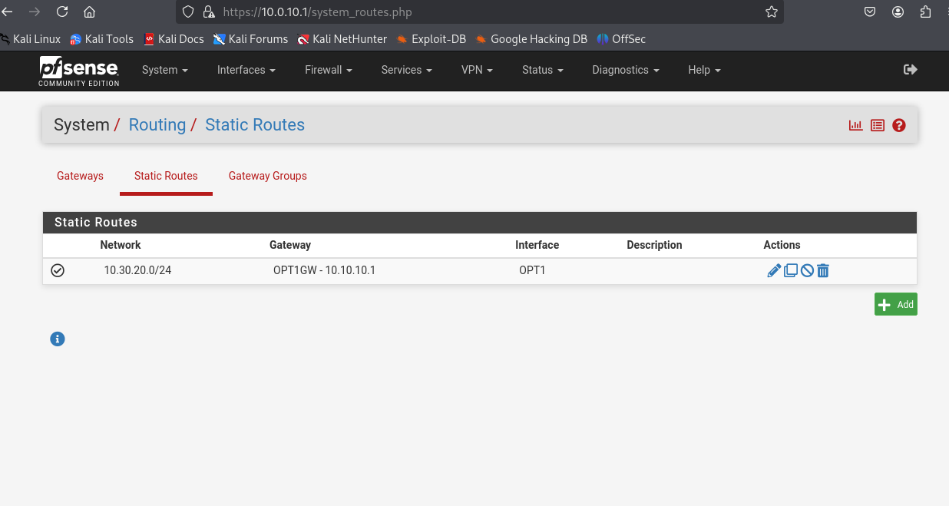

Next, configure the necessary firewall rules on both pfSense-L and pfSense-C. In each pfSense instance, navigate to **Firewall > Rules**, select the newly created WireGuard interface (e.g., OPT1), and add a rule to **allow all traffic from any source to any destination**. Additionally, under the **WAN interface**, create a rule to **allow incoming UDP traffic on port 51820**, which is required for establishing the WireGuard tunnel. These rules ensure proper tunnel communication and unrestricted traffic flow across the VPN.

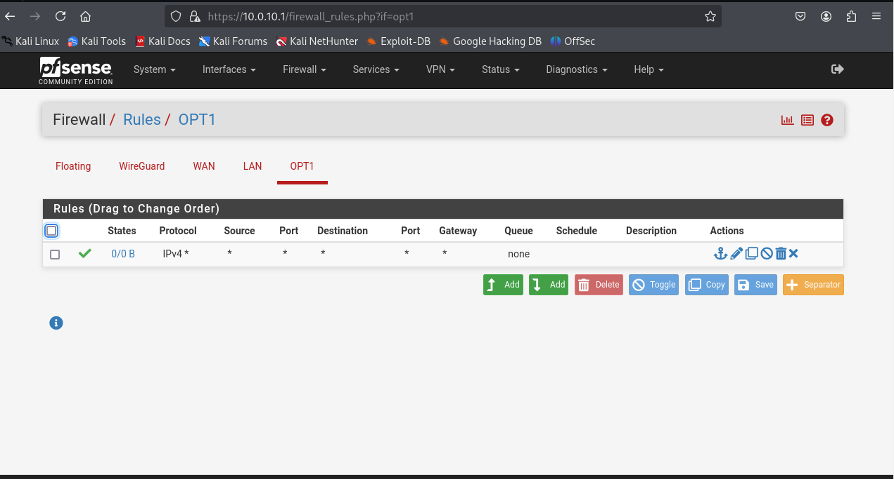

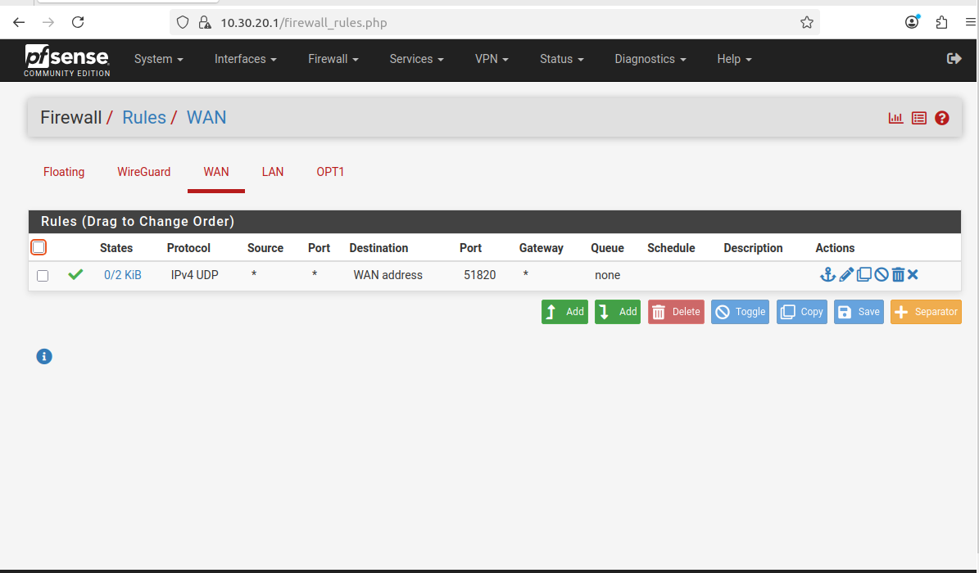

Next, verify the status of the WireGuard tunnel on both pfSense-L and pfSense-C by navigating to **Status > WireGuard**. A successful handshake should be visible on both ends, indicating that the site-to-site VPN tunnel is active and properly configured. To confirm connectivity, perform a ping test between the pfSense instances using their respective LAN IPs or tunnel IPs. The successful response confirms that the WireGuard tunnel is functioning as expected.

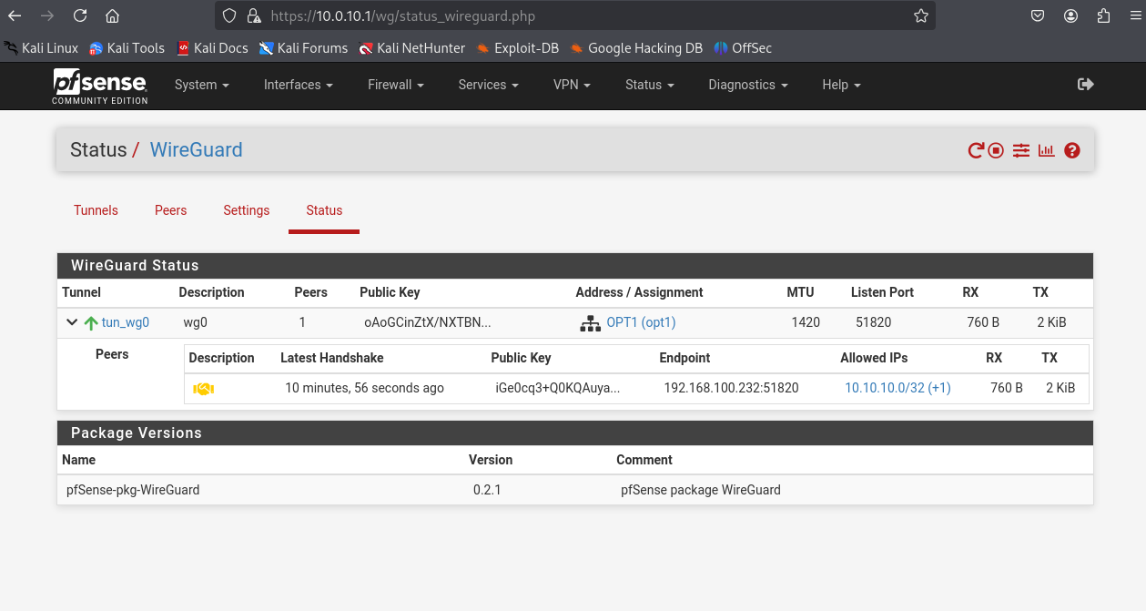

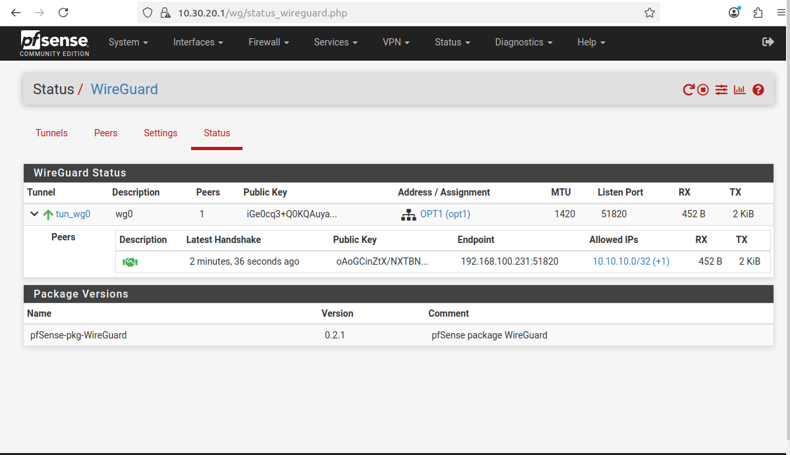

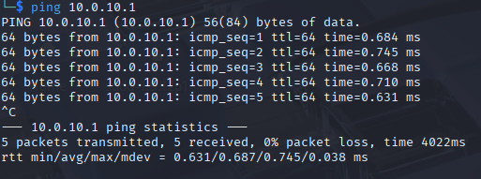

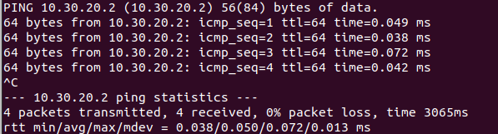

Zabbix Server & Proxies Installation & Configuration:

Zabbix Server:

Before installing the Zabbix Server on pfSense-L (within the local LAN subnet), several prerequisites must be fulfilled. Begin by installing and enabling the following essential services: **Apache2** (as the web server), **MariaDB** (as the database server), and **PHP** (for server-side scripting).

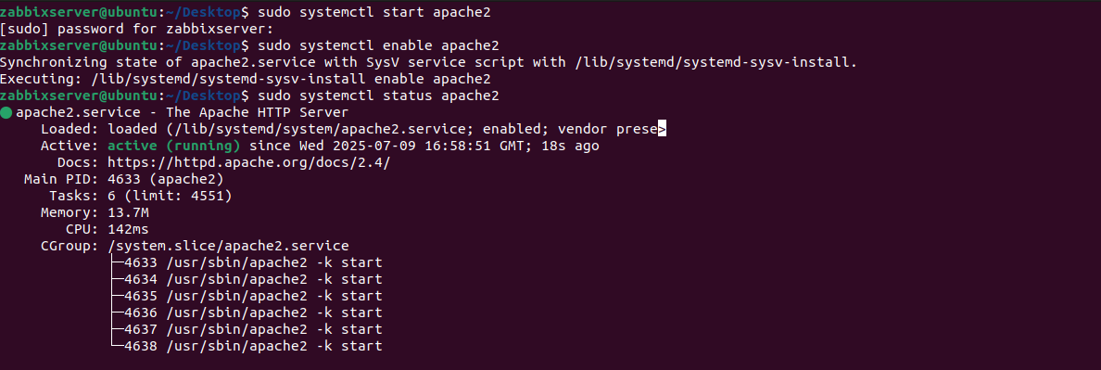

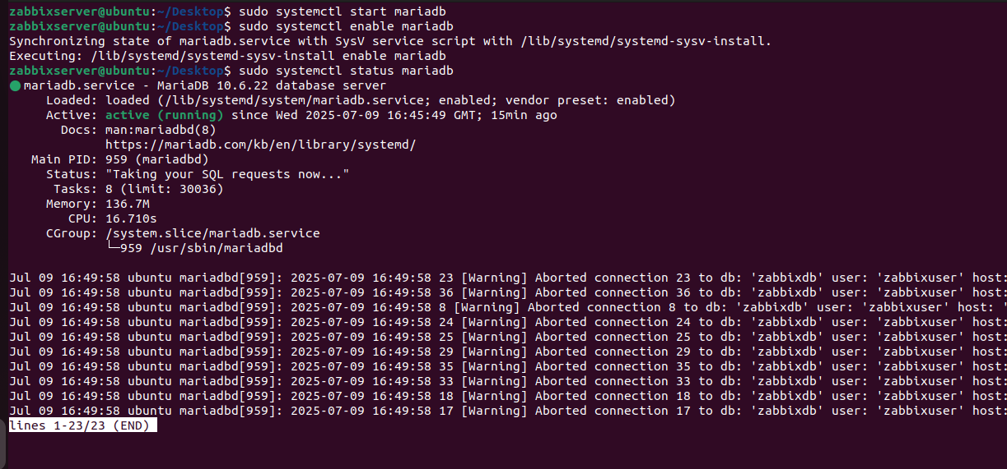

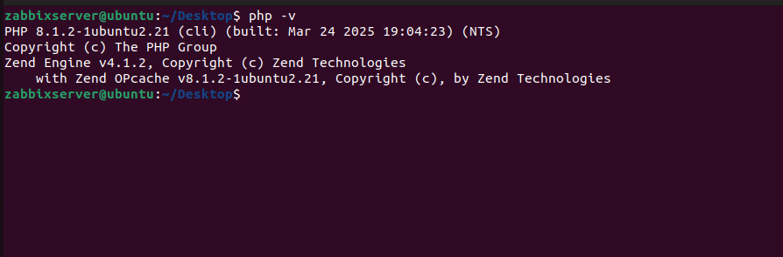

Once these components are installed and running, access the MariaDB shell to create a dedicated Zabbix database. Within the database environment, create a new user specifically for Zabbix, and grant this user **ALL privileges** on the newly created database. This ensures the Zabbix server has the necessary permissions to read from and write to the database during operation.

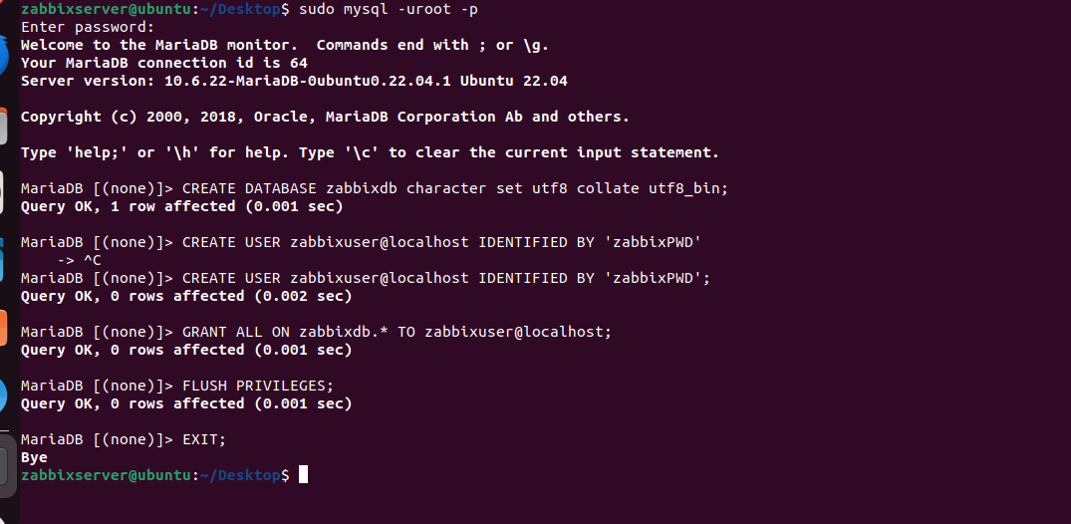

Next, navigate to the official Zabbix repository and select the **6.0 LTS** release, as this will be the version used for the Zabbix Server installation. Under the **Release** section, locate and copy the download link for the appropriate zabbix-release package that corresponds to **Ubuntu 22.04**, which is the operating system currently in use. This repository package will be used to configure the system to retrieve and install the Zabbix Server and related components from the official Zabbix package sources.

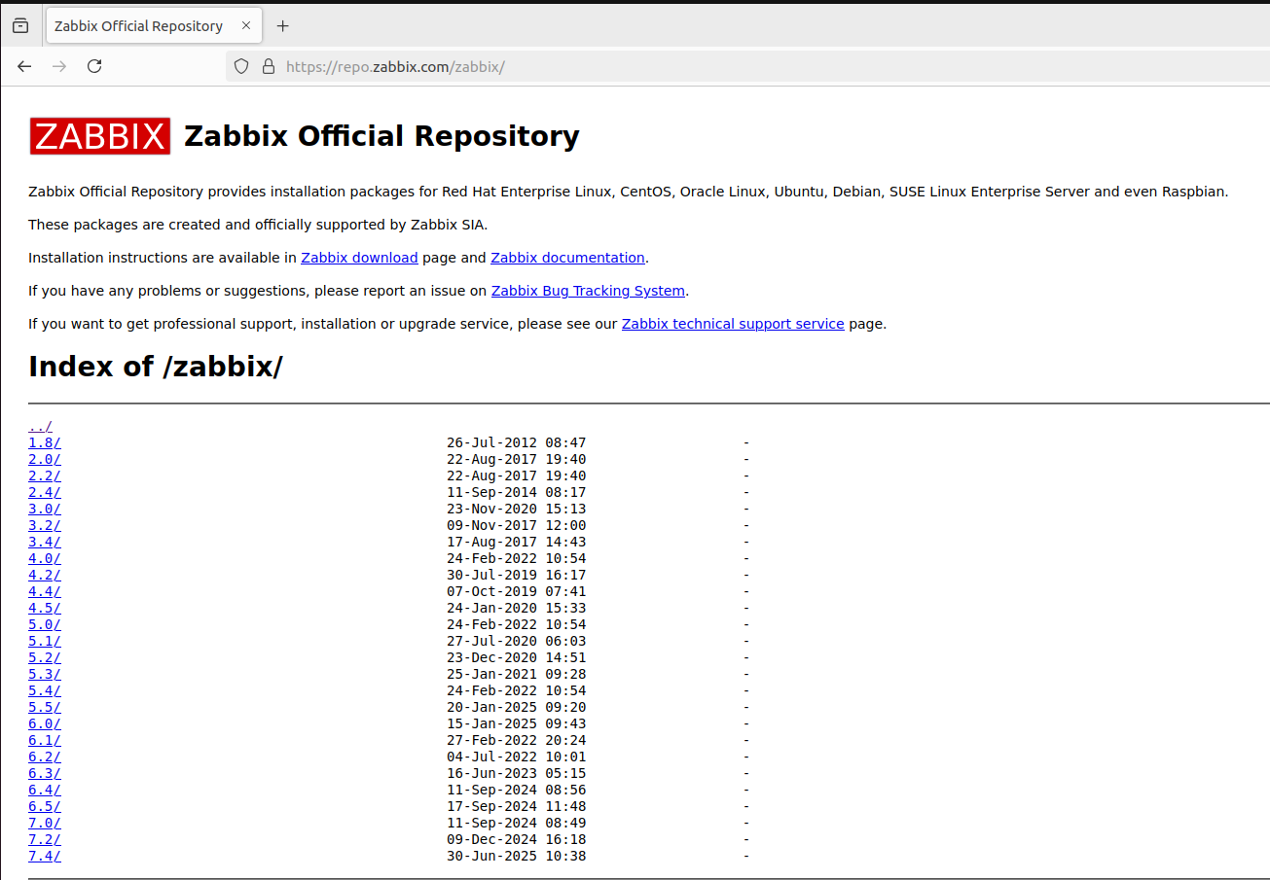

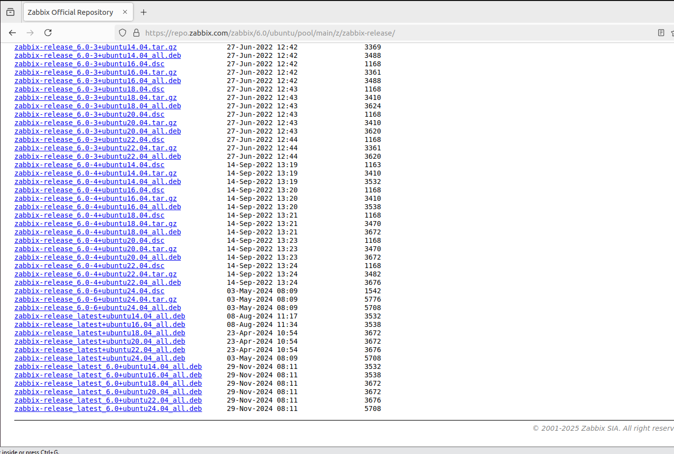

Download the Zabbix release package for version 6.0 corresponding to Ubuntu 22.04 by using the appropriate link from the official Zabbix repository. Once the package is downloaded, verify its presence and proceed to install it using the system’s package manager. This step adds the official Zabbix repository to the system, enabling the installation of Zabbix Server and related components directly via standard package management tools. After installing the Zabbix release package for version 6.0 on Ubuntu 22.04, update the system’s package index to incorporate the newly added Zabbix repository. This ensures that all Zabbix-related packages are available for installation through the system's package manager.

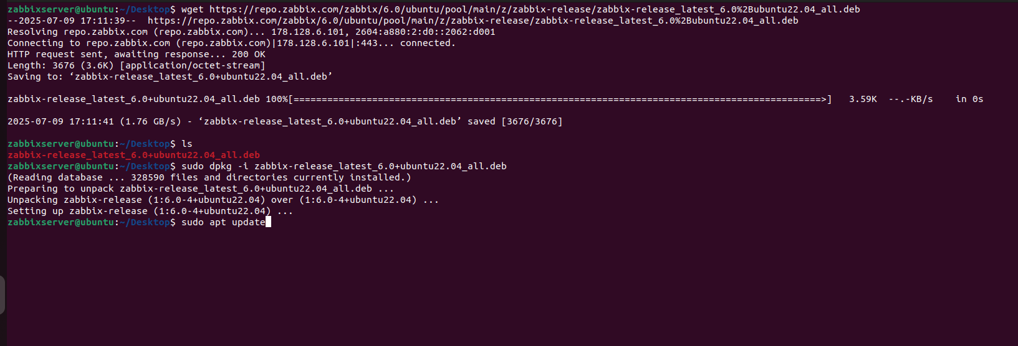

Now, proceed to install the Zabbix server by running the appropriate installation command, which will retrieve the necessary Zabbix server components from the configured repository and install them on the system, preparing it for further configuration and deployment.

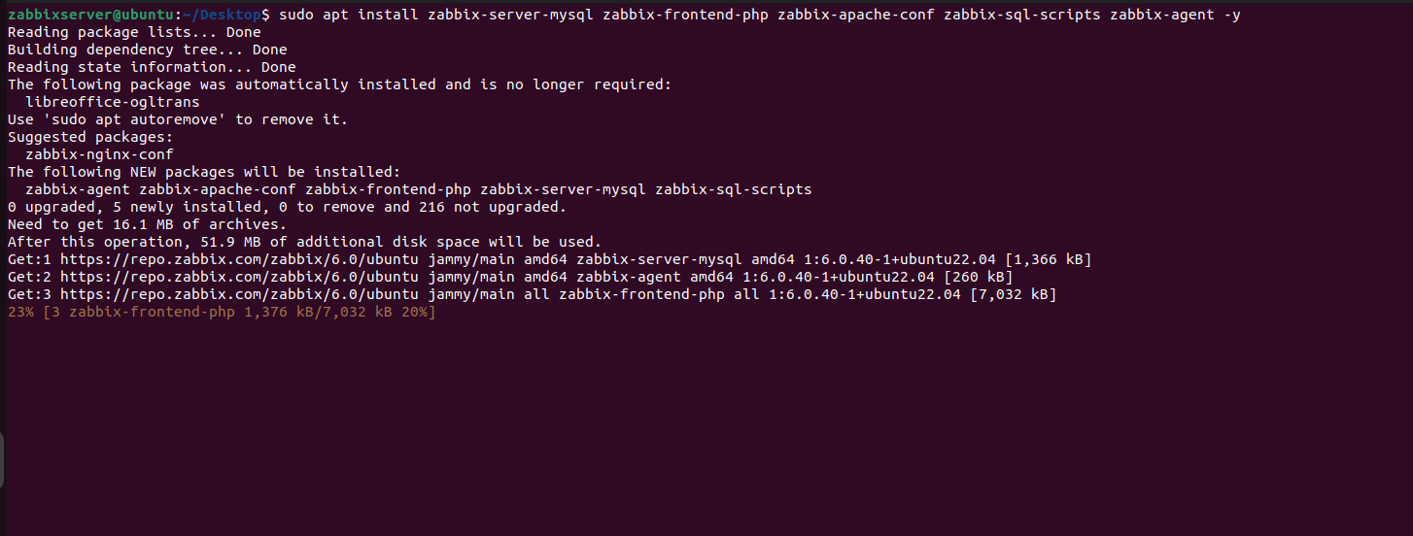

Next, start and enable both the Zabbix server and Zabbix agent services to ensure they launch automatically on system boot. Once enabled, check the status of each service to confirm they are running correctly and without errors. This step validates that the core Zabbix components are active and ready for use.

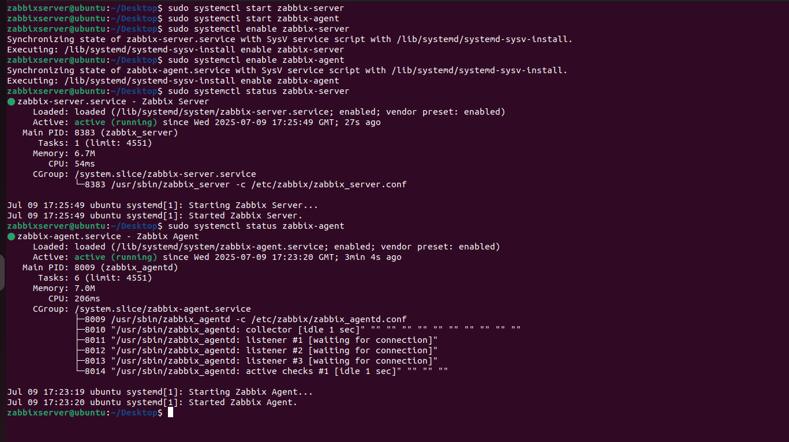

Next, open the Zabbix server configuration file and update the database connection parameters to match the values previously configured. Specifically, set the DBName, DBUser, and DBPassword fields to reflect the name of the Zabbix database, the associated database user, and the corresponding password. This ensures that the Zabbix server can successfully connect to the MariaDB database for data storage and retrieval.

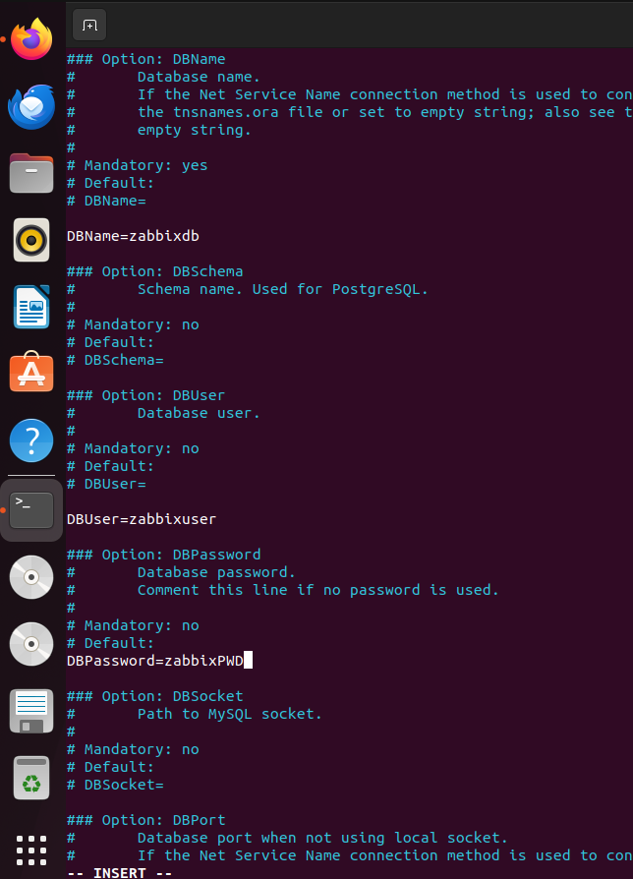

Once the Zabbix server and web components are properly configured and running, open a web browser and navigate to http://10.0.10.11/zabbix, which corresponds to the local LAN IP of the Zabbix server. This will launch the Zabbix web-based installation wizard, allowing you to complete the setup through a graphical interface.

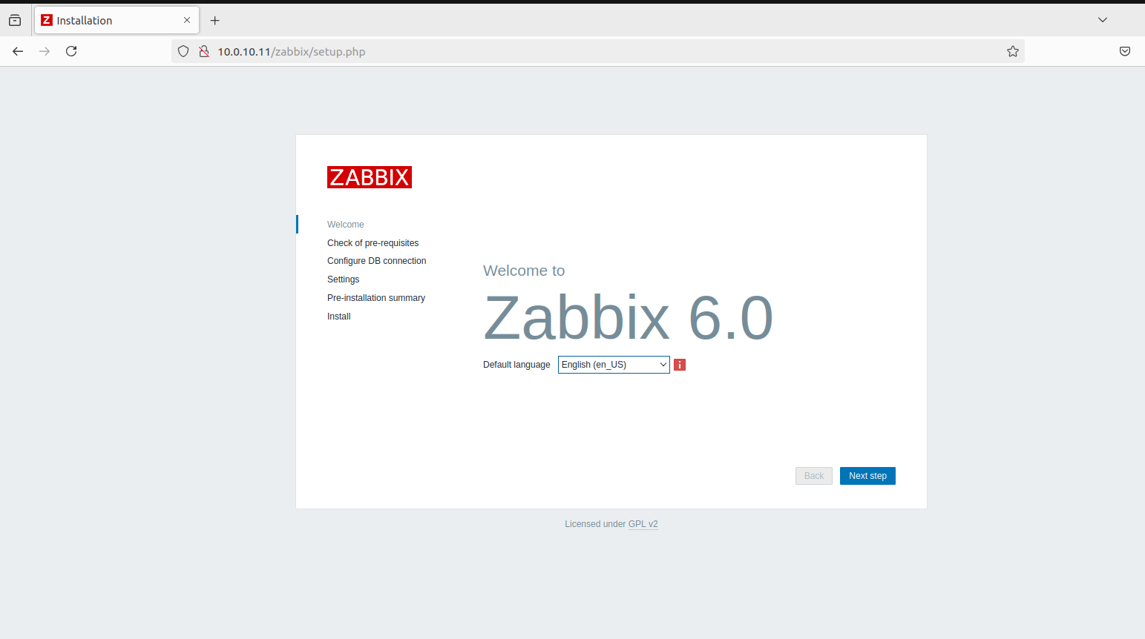

Proceed with the Zabbix web installation wizard by accessing the web interface at http://10.0.10.11/zabbix. Follow the guided steps, which include checking system requirements, confirming PHP settings, and entering the previously configured database details (database name, user, and password). Continue through the setup by specifying the Zabbix server details and setting the frontend language and theme preferences. Once all information is entered correctly and verified, complete the installation.

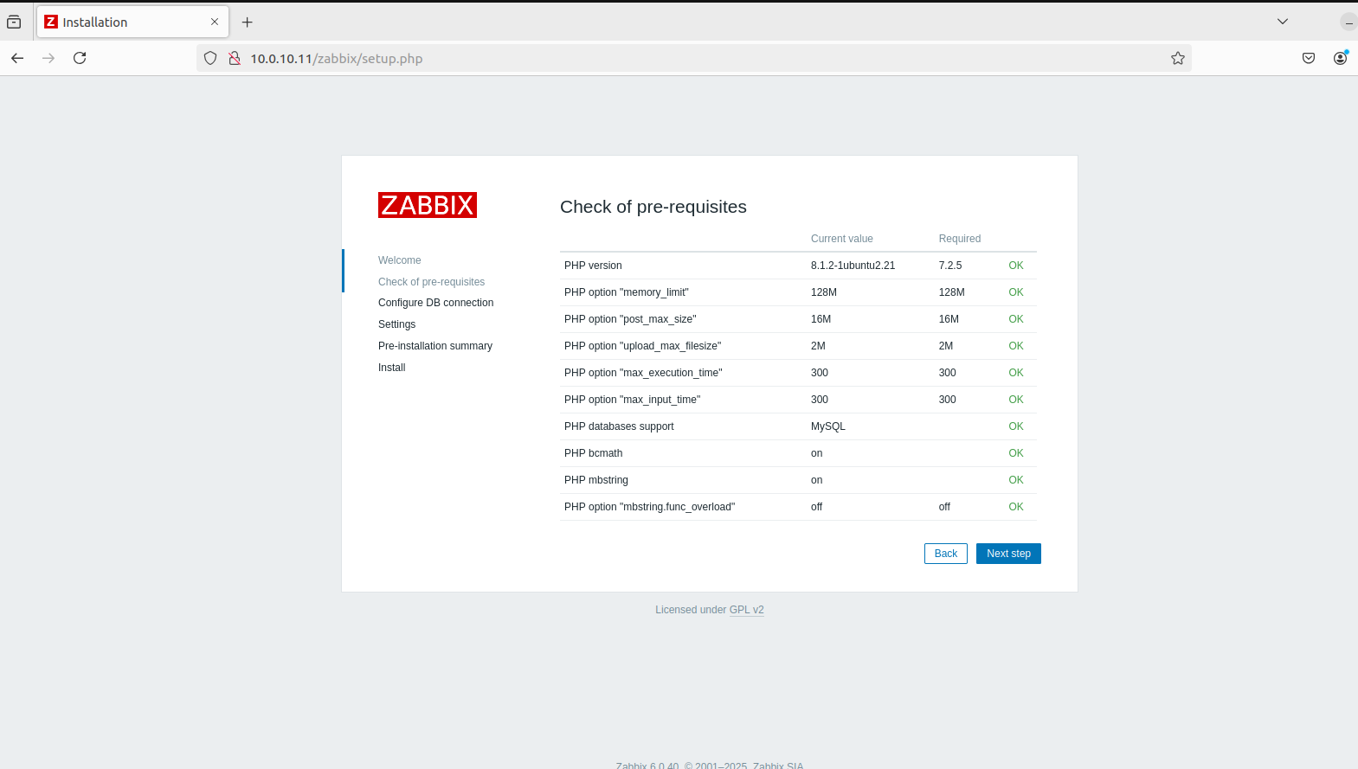

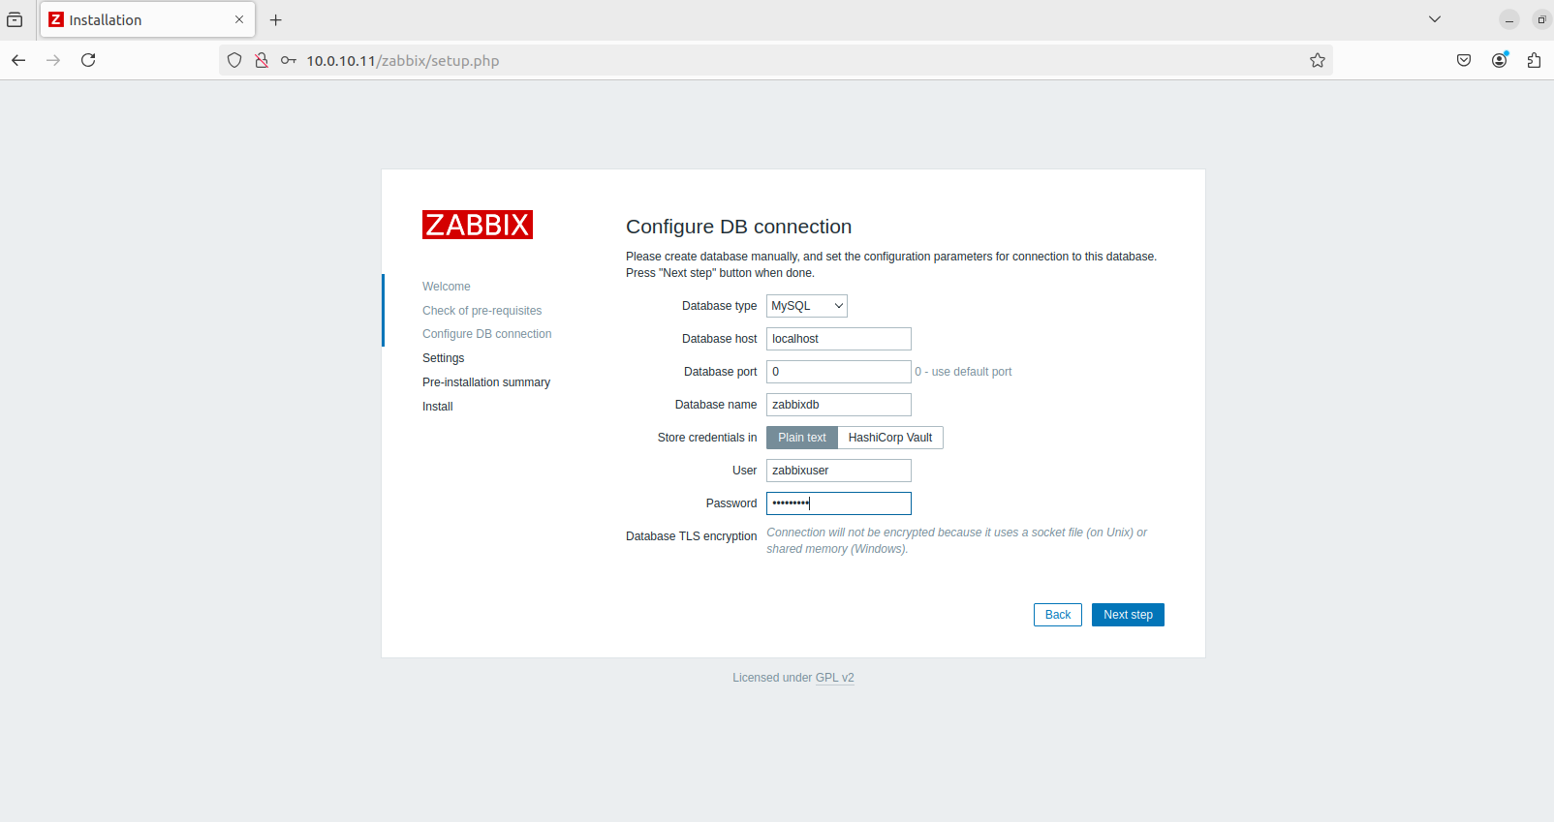

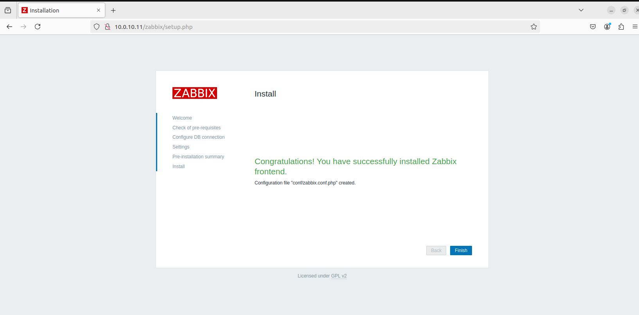

Upon successful setup, log in using the default credentials (Admin / zabbix) and finalize any additional configuration as needed within the Zabbix dashboard.

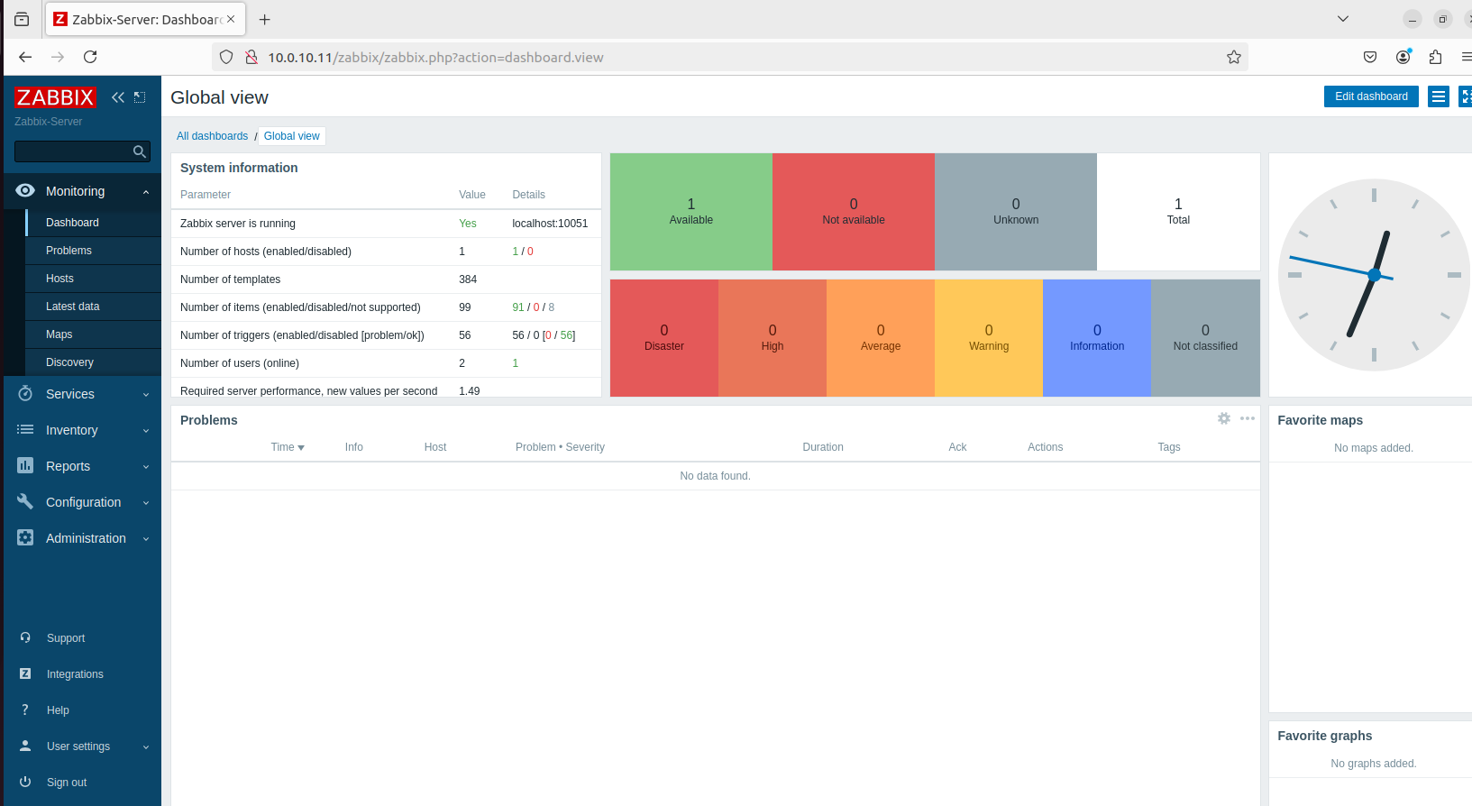

Zabbix Proxies:

Now, we will begin deploying two Zabbix proxies on the cloud side (pfSense-C), within the LAN subnet. For this purpose, two virtual machines have been provisioned—one running **Ubuntu 22.04** and the other running **Kali Linux**. Each of these VMs will be configured as a Zabbix proxy to facilitate distributed monitoring and reduce load on the main Zabbix server. This setup enables data collection from the cloud environment to be forwarded securely and efficiently to the Zabbix server located on the local side (pfSense-L).

Before proceeding with the installation of Zabbix proxy on both the Ubuntu and Kali Linux virtual machines, ensure that **MySQL Server** and **MySQL Client** are installed on each system. These components are essential for the Zabbix proxy to store and manage its local cache and configuration data before forwarding it to the main Zabbix server. Installing the database components beforehand ensures that the proxy has the necessary backend support to operate reliably in a distributed monitoring environment.

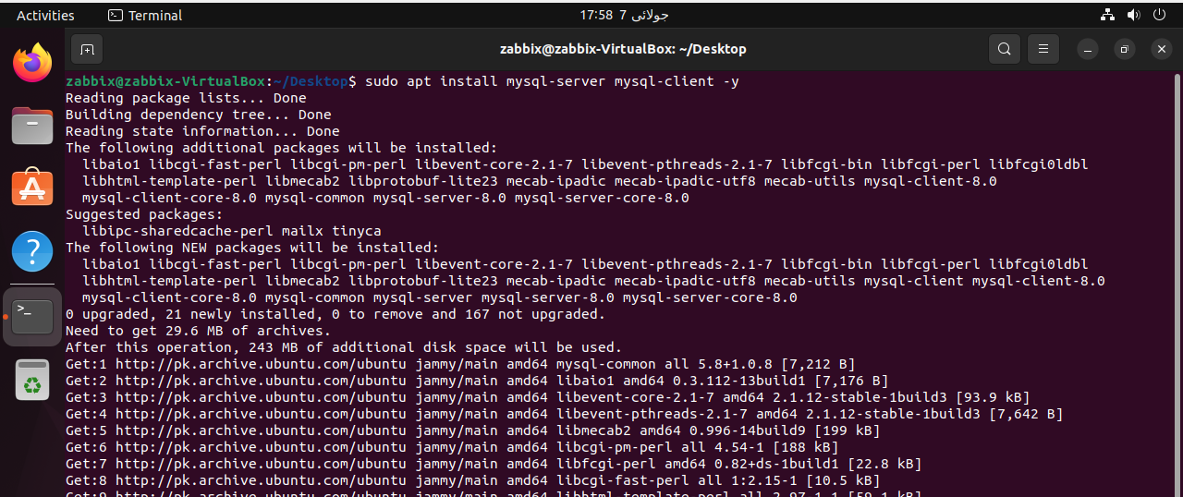

After installing MySQL Server on both the Ubuntu and Kali Linux VMs, start the MySQL service and enable it to launch automatically at system boot. Once enabled, check the service status to confirm that MySQL is running properly. This ensures the database backend is active and ready to support the Zabbix proxy installation and operation.

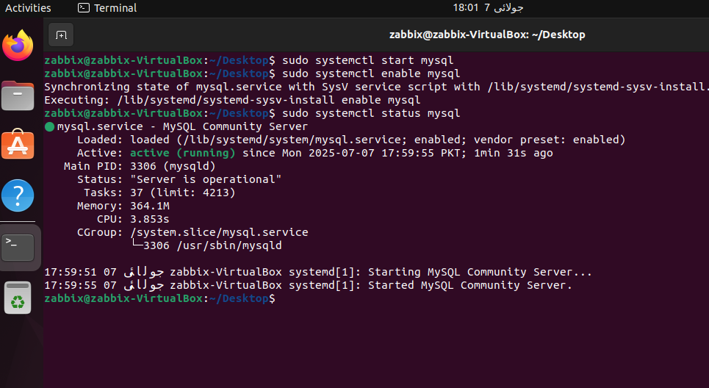

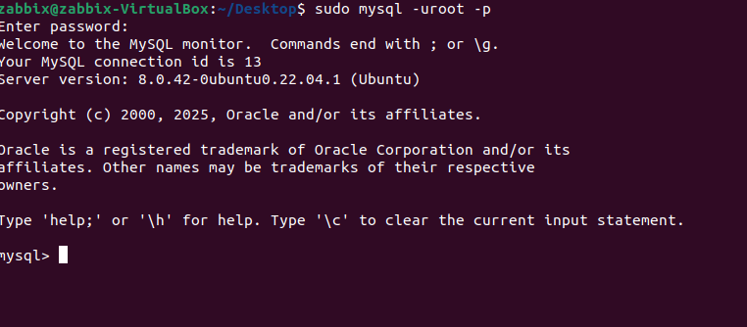

Navigate to the official Zabbix downloads page and select the appropriate configuration for the Zabbix proxy installation. In this case, choose Zabbix version 6.0 LTS, set the OS distribution to Ubuntu, and specify the version as 22.04 (Jammy). For the database type, select MySQL, as it is already installed and configured on the proxy machines. Once these options are selected, the site will display the necessary installation commands tailored for installing the Zabbix proxy on the specified platform. These commands include adding the Zabbix repository, updating the package list, and installing the Zabbix proxy package along with its dependencies.

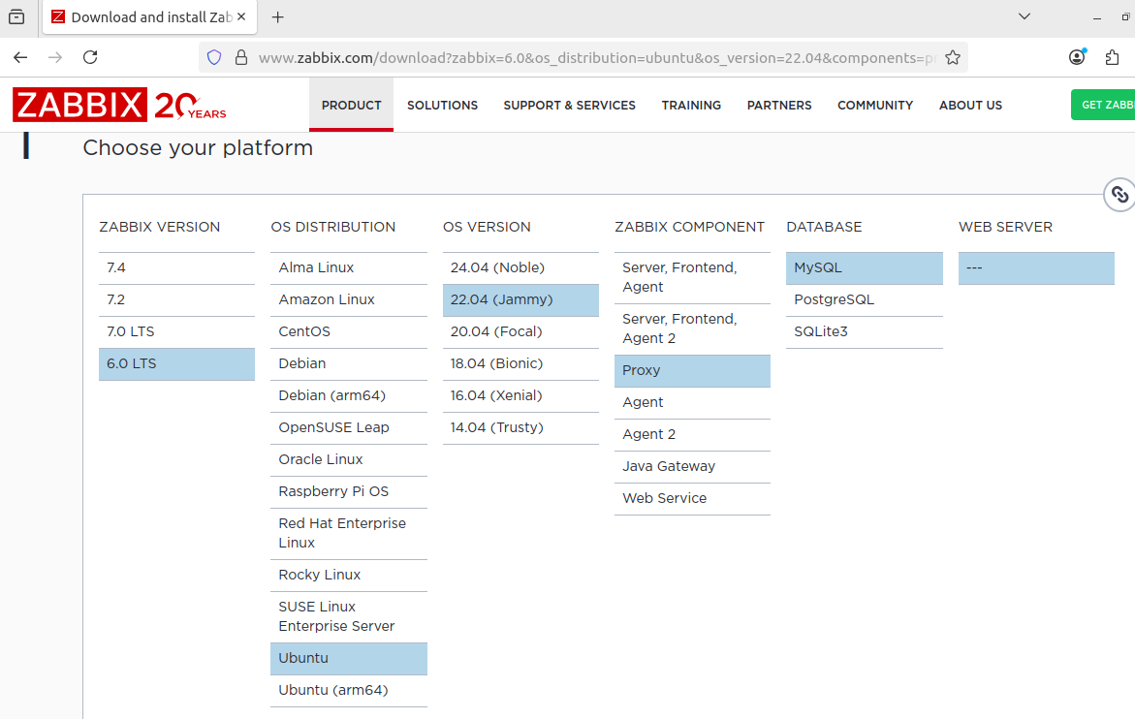

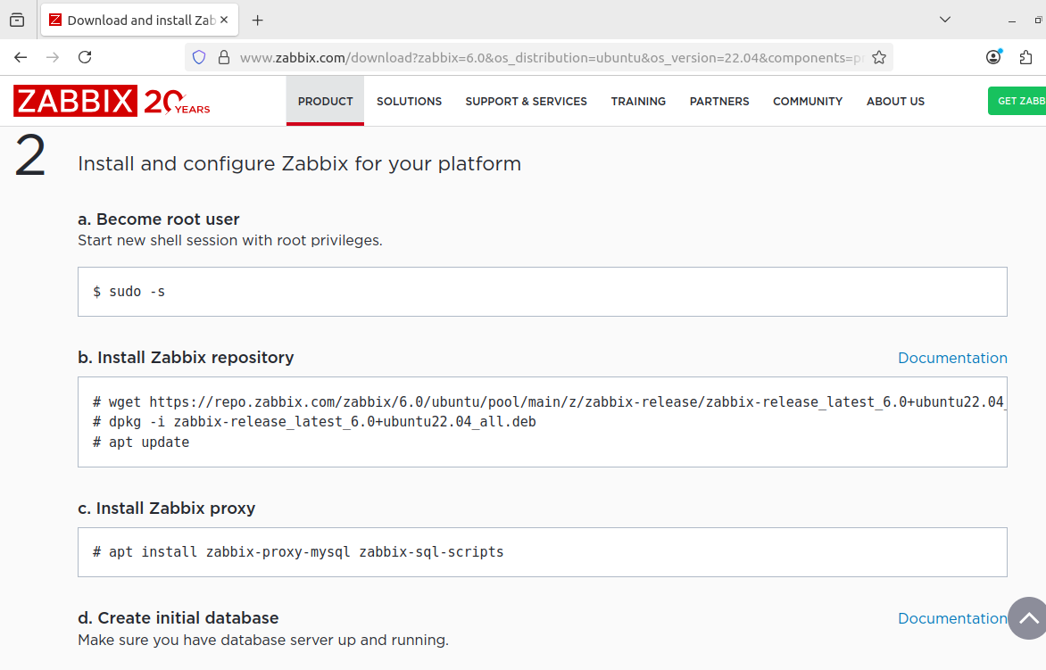

Now, execute the installation steps provided by the Zabbix downloads page for your selected configuration. Begin by running the wget command to download the appropriate Zabbix release package for version 6.0 on Ubuntu 22.04. After downloading, use dpkg -i to install the package, which will add the official Zabbix repository to the system. Finally, update the system’s package list using apt update to ensure all Zabbix-related packages are available for installation via the package manager. This prepares the system for installing the Zabbix proxy and its required dependencies.

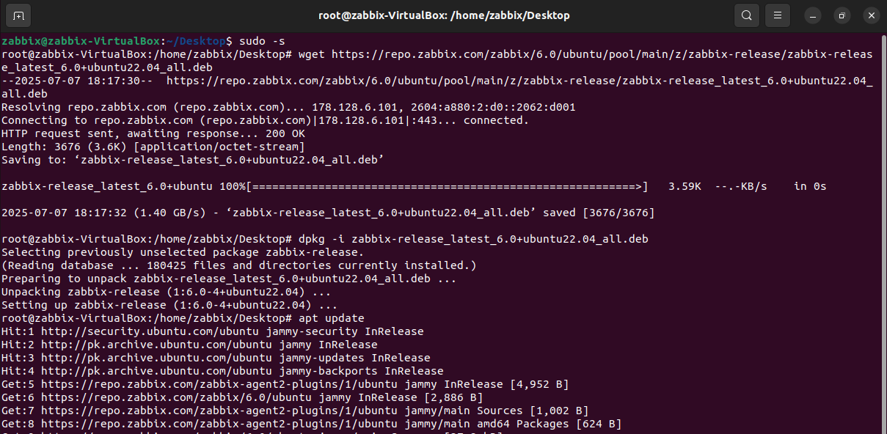

Next, proceed to install the Zabbix proxy with MySQL support along with the necessary Zabbix SQL scripts. This ensures that the proxy can operate using MySQL as its backend and is properly initialized with the required database schema. Use the command provided in the official Zabbix documentation to install the zabbix-proxy-mysql package, along with any additional packages that include the SQL schema scripts for database initialization. This step prepares the proxy to store configuration data locally and forward monitoring information to the main Zabbix server.

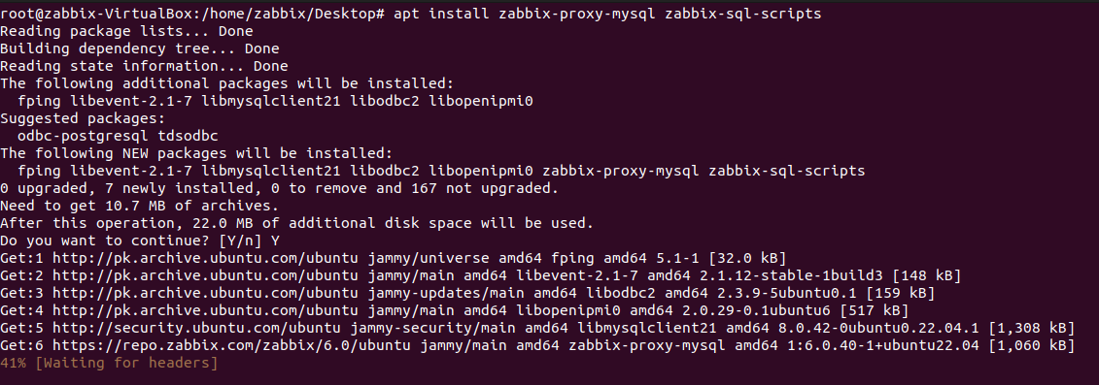

After completing the installation, start the Zabbix proxy service and enable it to launch automatically on system boot. Once started, verify the service status to confirm that the Zabbix proxy is running correctly and without errors. This ensures the proxy is active and ready to communicate with the main Zabbix server for distributed monitoring operations.

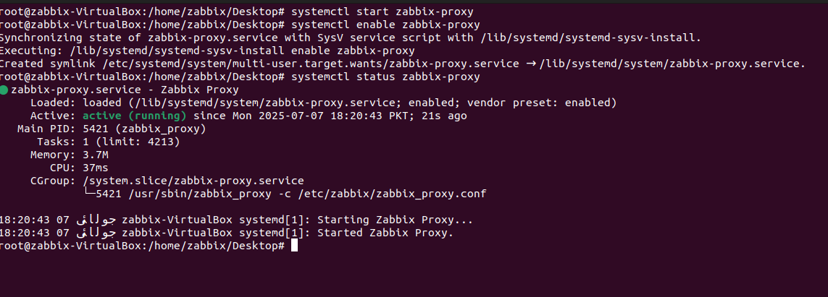

Now, access the MySQL shell on each proxy machine and perform the necessary database setup for Zabbix proxy operation. Begin by creating a new database dedicated to the Zabbix proxy. Then, create a new MySQL user, assign a secure password, and grant **ALL PRIVILEGES** on the newly created database to this user. Finally, set the global log_bin_trust_function_creators variable to 1 to allow the use of stored functions and triggers without requiring the SUPER privilege. This configuration ensures the Zabbix proxy can fully utilize the database features required for its operation.

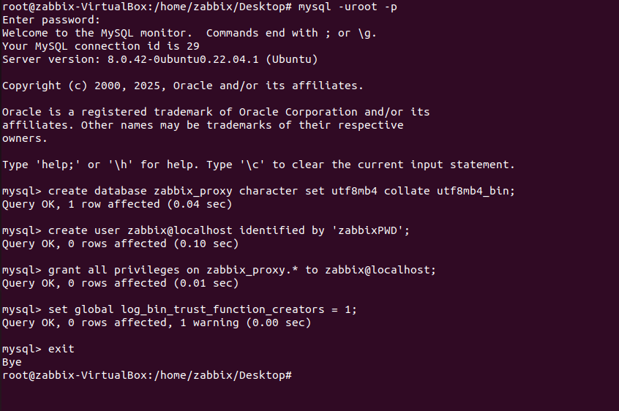

Initialize the Zabbix proxy database by importing the provided SQL schema file into the newly created MySQL database. This step sets up the required tables and structure that the Zabbix proxy needs to operate. It should be performed only once, immediately after the database and user have been created.

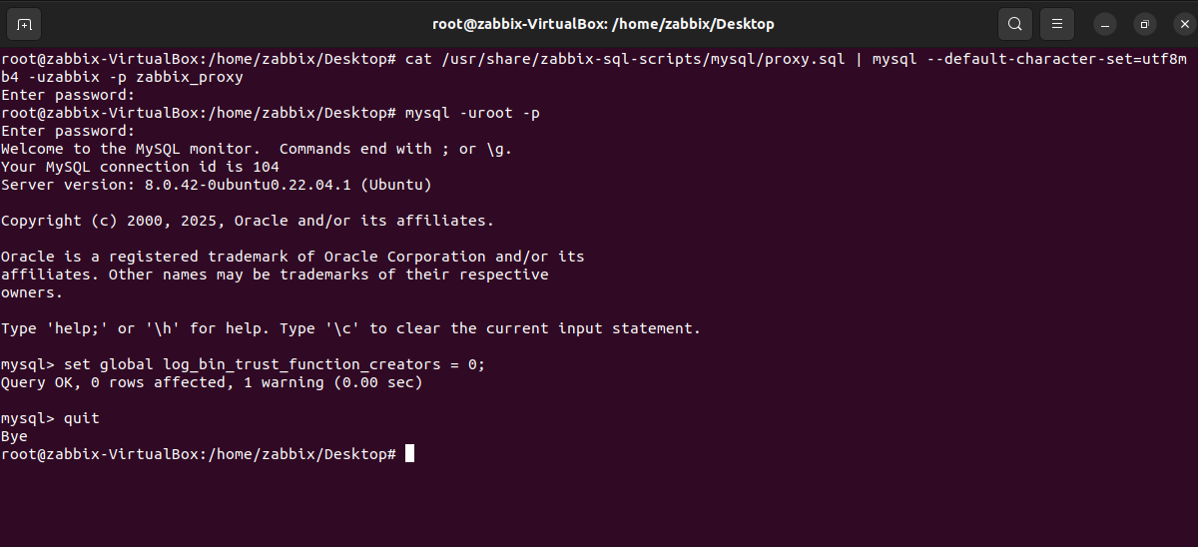

Next, update the Zabbix proxy configuration file located on each proxy machine. Uncomment the ProxyMode parameter and set its value to 0 to configure the proxy in **active mode**. Zabbix supports both active and passive proxy modes, with active mode allowing the proxy to initiate communication with the server. Set the Server parameter to the IP address of the Zabbix server (10.0.10.11), and assign a unique Hostname to each proxy—use proxy1 for the Ubuntu VM and proxy2 for the Kali Linux VM. This ensures proper identification and avoids hostname conflicts on the Zabbix server.

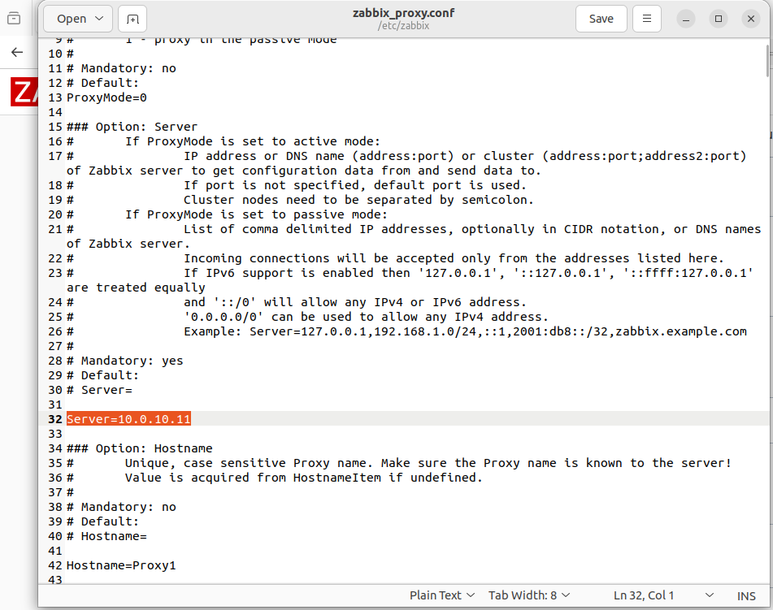

In the Zabbix proxy configuration file, also set the DBPassword parameter to the password that was assigned earlier when creating the MySQL user for the proxy. This ensures that the Zabbix proxy can authenticate and connect to the MySQL database without any issues during startup and operation.

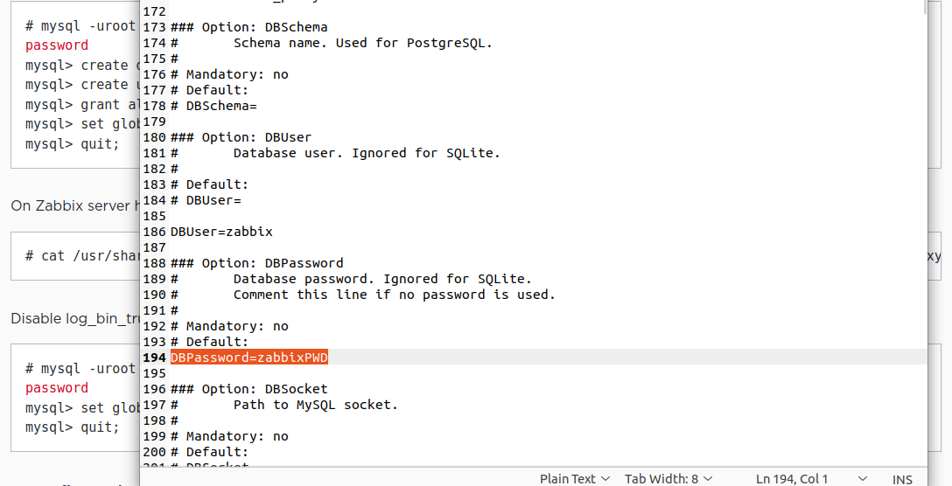

After completing the configuration, restart the Zabbix proxy service and enable it to start automatically on system boot. Then, check the service status to ensure it is running without errors. This confirms that the proxy is properly configured, successfully connected to its database, and ready to communicate with the Zabbix server.

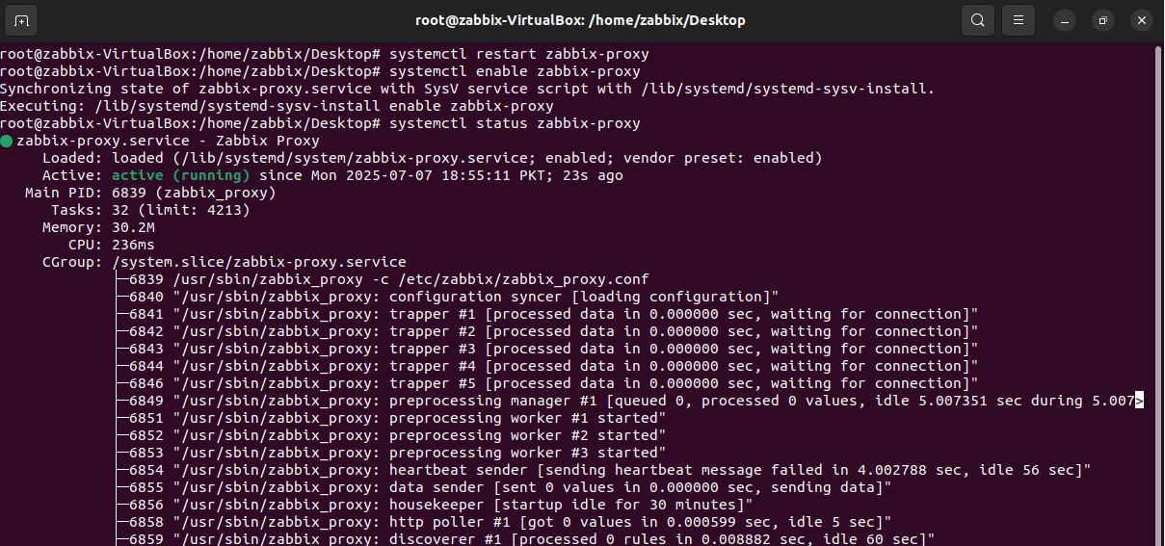

On the pfSense-L side, where the Zabbix Server is hosted within the LAN subnet, navigate to **Firewall > Rules** and select the interface associated with the WireGuard tunnel (e.g., OPT1). Add a new rule to **allow traffic from the 10.30.20.0/24 subnet** (Cloud side) **to the Zabbix Server IP (10.0.10.11) on port 10051** using the TCP protocol. This rule ensures that the Zabbix proxies in the cloud environment can successfully communicate with the Zabbix Server over the required port.

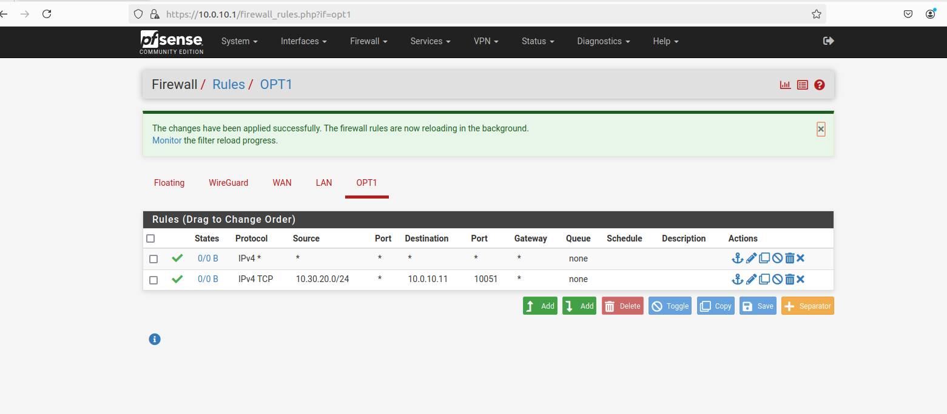

To verify connectivity, perform a Telnet test from each Zabbix proxy (Ubuntu and Kali) to the Zabbix server at IP 10.0.10.11 on port 10051. The test confirms successful communication as the response displays Connected to 10.0.10.11, indicating that the Zabbix proxies can reach the server over the required port and are ready for monitoring operations.







